Backwell Residents Association
AUTUMN NEWSLETTER
November 2016

Our AGM will be on Tuesday 21st February 2017 at 7pm
in the Sixth Form Lecture Theatre at Backwell School
Please put this date in your diary
We hope you will find this Newsletter helpful and interesting

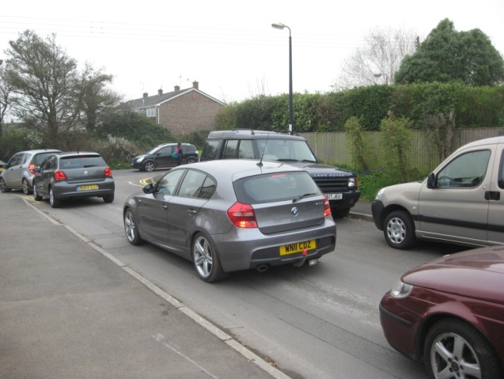
Moor Lane. The North Somerset Council (NSC) Planning Committee has recommended that consent be granted for up to 65 houses on land between Moor Lane and the railway line, subject to approval of conditions (e.g. sizes of houses, highway works etc). These conditions have not yet been agreed pending further discussion with the developer, Taylor Wimpey. The detailed application will follow subsequently. BRA, along with local residents, is concerned about the existing congestion in the section of Moor Lane between Station Road and The Briars (the access point to the new housing) which will inevitably be exacerbated by this development. The congestion is predominately caused by commuters unwilling to pay to use the station car park. In June our Secretary, who lives in Long-Thorn, attended a joint meeting with a representative of North Somerset Highways Department together with our North Somerset Councillor, Karen Barclay and BPC chairman Bob Taylor. A proposal to extend the double yellow lines in that section of Moor Lane was discussed, to improve access and visibility from Station Road, along with a box junction in Station Road. In the meantime, we understand that Backwell Parish Council (BPC) is attempting to arrange a further meeting with the developer and NSC Planning Department to discuss a more suitable mix of properties than currently proposed, in order to make provision for smaller homes to suit down-sizers and some bungalows for which there is a strong demand in Backwell .

Cars queuing in Moor Lane waiting to go into Station Road block one lane, and cars parked in Moor Lane block the other lane!

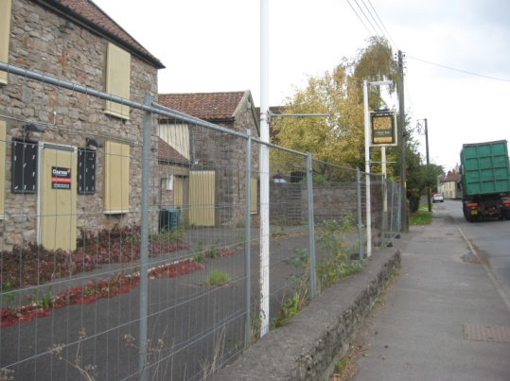

New Inn
We understand the new owner is shortly to submit a planning application for a small residential development, which would greatly improve this current eyesore in the village.
West of England Joint Spatial Strategy This is the next era of strategic planning – covering the period to 2036. National Government policy requires a large number of new houses to be built in the region during this period, together with further employment sites, new transport infrastructure etc.
Several possible scenarios are under consideration including new settlements in the regional centres, on the very edge of the main conurbations, and in well located service villages such as Backwell.
North Somerset Council is about to issue a consultation document which includes proposals for a further 3600 new dwellings in Nailsea and Backwell, to be built by 2036. Your committee is to consider how best to respond. This will include advice to members on how you can individually submit your comments.
You may have seen reports of a very large proposed new settlement (made up of 3 new villages) on land on the edge of Bristol, between Long Ashton and Dundry. This would provide at least 4500 new dwellings, and has been prepared as part of the answer to the Spatial Strategy requirements.

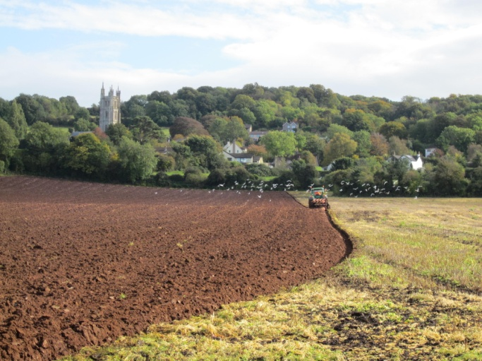
Farleigh Fields
BRA circulated a letter to all Backwell households recently, giving details of the appeal by Charles Church against NSC’s refusal to grant consent for 220 houses. We encouraged residents to support this refusal, and are delighted that around 200 households have already done so. This level of support is a huge help. BRA is working closely with BPC on a Steering Group chaired by BPC chairman, Bob Taylor. NSC will be opposing the appeal, leading on such matters as housing numbers.
What can you do to help?
1, Comment on the Appeal, as shown in the yellow letter. There is still time (just!) to beat the 31st October deadline. Your comments can be very short.
Comments need to go to the government Planning Inspectorate. Please ensure that your name is clearly given, and that you quote the full reference. This can be done in 3 ways quoting the reference APP/D0121/W/16/3153935 by Oct 31st at the latest
A. Via email to helen.skinner@pins.gsi.gov.uk
B. Via the website https://acp.planninginspectorate.gov.uk/
( using the reference 3153935 where prompted and “make representation”)
C. By posting 3 copies of your letter to Helen Skinner,The Planning Inspectorate, Room 3/O, Temple Quay House, 2 The Square, Bristol BS1 6PN
2. Note the date in May 2017 once it is confirmed and come to the inquiry at the Parish Hall.
3. We would be very interested to hear from anyone with a passionate interest in the fields (eg your family has walked them regularly for years). It will be helpful if locals could tell the Inquiry what the fields mean to them personally.
4. If you have any technical expertise in planning, traffic issues, agricultural land quality, environment which you could share please contact us.
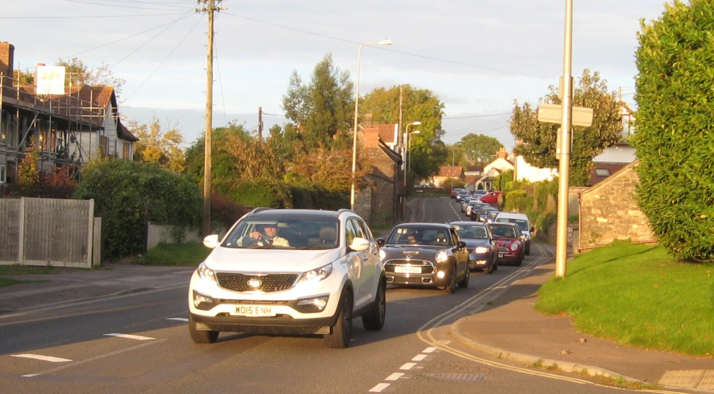
Evening rush hour traffic on the A370, at the junction with Church Lane coming into Backwell. Queues often stretch beyond The George, and extend down to the traffic lights at the cross roads

Ettrick Garage /Red Cross Preparation work for the development of 8 dwellings is on-going. Pre-commencement conditions are being discussed with NSC but they are taking some time. Benedicts Car Sales will remain in situ and trading normally for the time being.
Backwell Household Waste Recycling Centre (HWRC). NSC has 3 HWRCs, but only Backwell's Centre is close to a residential area. Like the airport, it generates traffic and noise which can be an inconvenience to those living close by, but most of us find it a useful facility! There has been some press comment on the possibility of reduced hours and/or Sunday closing, which would please some people, and inconvenience others. BRA is active in the Liaison Group meetings which are useful opportunities to exchange views on the operation of the site. The new contract with Biffa starts next March and includes a requirement for skip lorries to avoid using Dark Lane at school in/out times. The Junior School, BRA and many parents have campaigned for this in recent years.
If you are concerned about noise at the HWRC site you can telephone the Environment Agency on: Freephone 0800 807060, press 1 and hold to speak.

Traffic Concerns.
There are increasing concerns about the volume and speed of traffic on many roads in the village, particularly Station Road, Dark Lane and the A370. We would like to urge all residents to comply with speed limits and take particular care at school in/out times. BRA was briefed by the police on the details of Community Speedwatch schemes, where volunteers in “hi vis” clothing operate a “gun”, and are able to initiate a warning letter from the police to speeding motorists. There are schemes in some North Somerset villages, with mixed results – some have experienced difficulties in recruiting volunteers. The BRA committee would be interested to hear the views of members on the pros and cons of Speedwatch. Traffic calming measures in Dark Lane were included in the conditions of the Coles Quarry redevelopment last year and are still being considered by BPC with NSC.

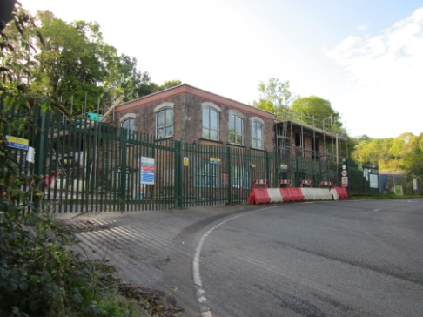
Coles Quarry The developers are continuing, very slowly, with the refurbishment of the old weighbridge house at the front of the site. There has been minimal recent progress with works further into the site, as they continue to try and negotiate a revised planning consent. BRA continues to monitor progress and liaise with the developer’s agent.

Stancombe Quarry Community Fund.This Fund has been set up under a Section 106 Agreement related to Planning Consent for an extension to the Quarry, which is a large operation in Backwell Parish, accessed along Stancombe Lane near Flax Bourton. The Quarry owners, Tarmac, will pay 2p into this fund for every tonne of limestone extracted. This may not sound much but it amounts to about £20,000 per year. Social and sporting organisations and Community projects in the Parishes of Backwell, Flax Bourton and Barrow Gurney can apply for funding to assist with deserving initiatives. The applications are considered and voted upon by a panel of six people, two from each Parish. The Backwell votes are split between BPC and BRA. The first batch of five applications were all agreed, and we are pleased to report that three of these are in Backwell. The Junior School will receive £5000 to assist with refurbishment of its library and IT room. Backwell Parish Hall has been granted £5000 towards the cost of replacing doors and Backwell Playing Fields Charity will receive £2150 towards additional safety fencing. The next batch of applications has a cut-off date for submissions of 31.1.17. Application forms can be downloaded from the BRA website.
Bristol Water The big project to link Barrow and Cheddar reservoirs (Southern Resilience Scheme) has started in Backwell with trial holes. There will be major disruption in the village for several months starting in mid-2017, when the real action starts. Bristol Water will be arranging a public meeting next year, to explain the implications of their work, which will involve several significant road closures. Further information is available from rob.ellis@bristolwater.co.uk or Caroline Granville on 0345 702 3797.
BRA Membership We shall be having a recruitment/renewal drive from January 2017, when our membership year starts, prior to our AGM on 21st Feb. As ever, membership numbers are very important for everything we do. By then, we should know more about the Farleigh Fields inquiry costs in relation to our current funds. We may need to request donations from our members (and others) to boost our modest reserves. More details in our January Newsletter.
Visit our website on www.backwellresidents.org.uk
Email us at backwellresidents@btinternet.com

