Backwell Residents Association
NEWSLETTER - January 2019

Please come to our AGM on Tuesday 12th February at 7pm
in the Sixth Form Lecture Theatre at Backwell School
Please pay your £10 membership now or at the AGM
(membership form on the back page)
All members and non- members are welcome to attend

In March last year we were delighted that the Secretary of State supported the refusal of the application to build 220 houses on Farleigh Fields (FF). This year there is an even bigger challenge! 700 houses are proposed on Grove Farm, and unlike the FF process, North Somerset Council (NSC) is a party to the proposal, and is not alongside Backwell organisations and residents who oppose it. This time we are on our own!!

2019 will see continuing progress on smaller projects for up to 25 houses in total, developments on the Coles Quarry site and probably work starting at Moor Lane on 62 houses.
In this newsletter, which is delivered to all Backwell households by our volunteers, we bring you up to date in advance of our AGM, where the projects will be discussed and you will be able to have your say.

We are pleased that so many members have provided us with an email address, which helps us keep in regular touch, with dates for making comments on planning applications, road closures and other matters. Please also look at the BRA website, where there are tabs for all the main issues mentioned below, with links to the many documents and letters we have written on them.

West of England Joint Spatial Plan (JSP)

At the risk of repetition for those familiar with the proposal, the Plan has been created by the 4 councils (Bristol City, Bath and North East Somerset, South Gloucestershire and North Somerset (NSC) known as “West of England”. The JSP allocates housing across the area up to 2036. Unfortunately, Backwell is one of 4 villages in the NSC area allocated a “new community” on its doorstep, with a proposal for 700 houses with building starting in 2028. The land is around Grove Farm to the west of Backwell.

The schematic map below shows the main features of the proposal

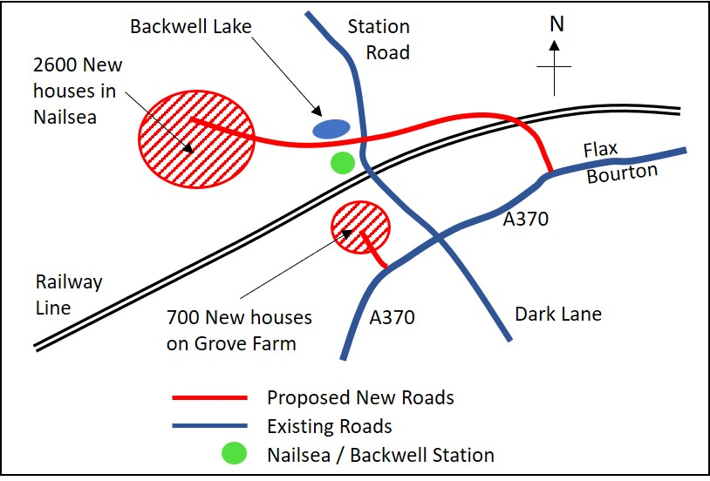

It is evident that there is almost unanimous horror at the prospect of such a huge development on agricultural land close to Backwell, where the infrastructure is barely coping at present. Among the proposals, Nailsea & Backwell station will become a “transport hub”, with much more parking, and new roads as shown on the map. It is unsustainable and inappropriate, and we do not consider the associated infrastructure changes to be affordable.

Thank you to the hundreds of Backwell residents who have taken the opportunities to comment on this – the last closing date was 7th January. The next part of this drawn out exercise is a public hearing – expected to be confirmed for May / June. This is where technical arguments are pivotal against the backcloth of the very important public comments, and representatives from Backwell organisations as well as our appointed consultants will be invited to participate.
A final decision is not expected before the end of the year, and the outcome is unclear. It is uncertain what role members of the public may take at this stage. Fortunately, an expert planning consultant lives in Backwell, and she has already contributed to our responses to the JSP. She will be a key figure at the hearing, along with transport and ecology consultants. We are equally fortunate that 3 very different village organisations, Backwell Parish Council (BPC), BRA and Backwell Resistance (BR), have combined their efforts and are members of the BPC working party. BRA has already contributed financially, and has pledged further funds for later this year.

North Somerset Local Plan (LP)

Following on the heels of the JSP is an emerging Local Plan for the period to 2036, which is designed to replace the current Core Strategy. Not surprisingly, this LP follows very similar principles to the JSP, and includes the same 700 dwellings proposal for the Grove farm site on the edge of the village.
Many of you made representations in December to the "Issues and Options Document" (as did
BRA, using professional advisors). BRA and BPC have met North Somerset officers to make clear our objections to this draft plan and it is yet to be seen if the next draft is very different. This process will continue during 2019, with a final approved plan not expected until well into 2020.

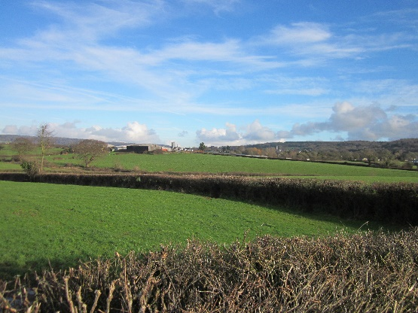
Grove Farm site

The BPC working party (which includes BRA representation), has met Taylor Wimpey on several occasions to clarify its position and express their objection to the scale of their proposals. The developer plans to submit an application for 700 dwellings this Spring (i.e. before the JSP Hearing). There will be ample opportunity for further discussion and comment on the details of this expected application in due course. Please be ready!

A PLEA FOR FUNDS

Membership of BRA. 2019 is likely to be another expensive year for BRA and BPC in opposing the development of 700 houses. We urge our previous members to renew their membership as soon as possible. We hope that other residents will also join, particularly those in Backwell Resistance who obviously share our view. The £10 subscription is an efficient way of increasing the fighting fund in the village. A membership application / renewal form is attached at the back of this newsletter. Our main method of communication is by email – please make sure you provide us with an up to date email address, so that you can receive rapid communications.

Moor Lane (15/P/1916/O) Negotiations on the fine detail of this Taylor Wimpey application seem to have been going on forever. It seems final approvals for the 62 houses are now imminent, including clarification on some extra parking controls in Moor Lane itself. Development is anticipated from this Spring onwards.

Coles Quarry (14/P/0304/F and 16/P/0674/F) We understand negotiations are again well advanced on a revised 2016 planning application. If granted, it will include development of 16 small industrial units, and a re-configuring of the access to the recycling centre. Revised details are expected shortly, which will include a timetable for public comment.

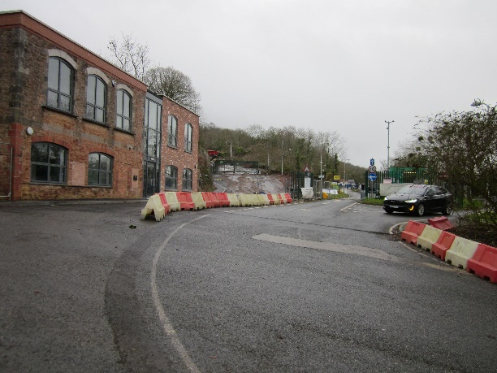
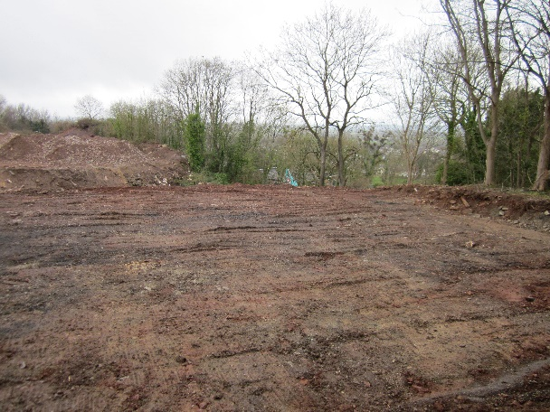

Area behind the Weighbridge building Road up to the top level between the
being prepared for industrial units weighbridge and the “tip” entrance

New Inn site (17/P/0430/F) After a lull, we understand development of 9 dwellings and an office is due to commence this spring. The New Inn building is being converted into two semi-detached houses and an office. The new building on the frontage is to be two semi-detached dwellings. A further 5 dwellings are planned for the rear.

New Build Refurbished New Inn Building
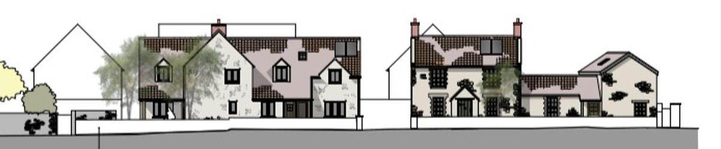
Street view from A370

Ex BT Research Station, Backwell Hill (17/P/1935/O) Despite being in the Green Belt, consent was granted last spring on this remote site for four “eco houses.” No date is yet available for a development start. We have seen advertisements seeking funding.

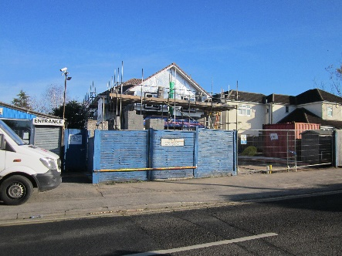
Chorleys Yard, Dark Lane (18/P/3105/FUL) After some false starts, consent was granted in the summer for two dwellings next to the old MICA shop. Their construction is already far advanced

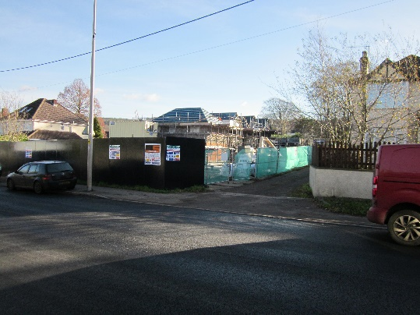
Ettrick Garage/Red Cross Hall site (18/P/4269/MMA) This development of 8 small houses is well underway, with completion expected by late Spring.

Bristol Airport Our bulletin of Jan 9th was devoted to this application. The closing date for public comments on the application to expand passenger numbers up to 12 million a year (currently 8m) was Jan 26th. There is a balance between the benefits and convenience of a local airport with saving on travel to more distant airports, versus ever increasing impact locally through noise, pollution, clogged up inadequate roads, damage to the environment and green belt encroachment. The next stage will be the consideration of the application by NSC.

Station Road Following the increasing concerns about safety along Station Road, especially for pedestrians, North Somerset Council (NSC) allocated funding, and a package of work was carried out early last autumn. This gave rise to a number of letters in the North Somerset Times, some in support and some complaining about the adverse impacts on car travel. We sense that the overwhelming majority of residents consider the measures to be an improvement. In particular, walking and cycling along this narrow, busy road generally feels much safer, which was the whole point of doing the work. We understand that the Parish Council is now intending to consider a 20mph speed limit throughout the village, apart from the A370. Please make your views known, either direct to the Parish Office, or via the BRA Committee.

Improved Access to Nailsea / Backwell Station Platform There has been a very disappointing lack of progress. It seems Network Rail is still deliberating about the design and trying to secure the necessary funding. The BRA committee will continue to support the campaign for better station access wherever possible.

BACKWELL RESIDENTS’ ASSSOCIATION
This year’s ANNUAL GENERAL MEETING will be held at 7.00pm on Tuesday 12 February 2019 in the Sixth Form Lecture Theatre at Backwell School (entrance via Meadow Close off Station Road)
AGENDA
- Apologies for Absence
- Approval of 2018 AGM Minutes (available on website or on request to Hon. Sec.)
- Chairman’s Report
- Membership Report
- Honorary Treasurer’s Report and Audited Accounts for year to 31 Dec 2018.
- Election of Officers* Honorary Secretary, Honorary Treasurer and up to ten Committee Members. The following Nominations have been made at the date of this Notice:
Hon Secretary | Mike Veal | Proposed | Judy Thomas | Seconded | Geoff Wells
Hon Treasurer | Kevin Crawford | Proposed | Richard Ivens | Seconded | Keith Riches

The following Committee Members, having served three years are retiring at the Annual General Meeting and offer themselves for re-election.

Committee Member | Richard Barclay | Proposed | Graham Bowerman | Seconded | Valerie Wells
Committee Member | Margaret Kemp | Proposed | Bill Charnock | Seconded | Gill Collinson
Committee Member | T.Merrett-Smith | Proposed | David Andrews | Seconded | Jane Elliott
Committee Member | A Ribbon-Miles | Proposed | Rachel Beckingsale | Seconded | Mairead Dent
Committee Member | Keith Riches | Proposed | Phil Collinson | Seconded | Andy Pitcher
Committee Member | Mike Rose | Proposed | Jeanne Craske | Seconded | Chris Perry
Committee Member | Geoff Wells | Proposed | Graham Hackett | Seconded | Pam Marchant
Committee Member | Valerie Wells | Proposed | Norma Knight | Seconded | Tim Lewis
Committee Member | Two vacancies*

- Appointment of Auditor:

Auditor | Richard Gaunt | Proposed | Kevin Crawford | Seconded | Mike Veal

8. Any Other Formal Business
9. Guest Speaker and Open Forum
*Nominations for the Committee vacancies should be made to the Honorary Secretary, 36 Longthorn, Backwell, BS48 3GY at least 24 hours in advance of the Meeting. Nominations must be proposed and seconded by members in full membership for not less than three months prior to the Annual General Meeting and signify the nominee’s willingness to serve. Members are reminded that the Committee has authority to co-opt additional members as necessary to undertake specific roles. We are particularly interested in recruiting a Committee member with knowledge or experience of planning law and procedures. Please contact the Chairman or Secretary if you would like to discuss this possibility.

NB The Meeting is open to all Backwell residents but only paid up members may vote or make nominations. The formal aspects of the AGM will be kept to a minimum so that we can devote most of the time to the matters covered in the attached newsletter and other matters raised by members.

Current Elected Committee Members:

BARCLAY, Richard
COLLINSON, Gill - (Recruitment)
CRAWFORD, Kevin - (Treasurer)
ELLIOTT, Chris
KEMP, Margaret - (Membership & Web Manager)
MERRETT- SMITH, Terry - (Asst. Treasurer)
RIBBON-MILES, Angela - (Social Media)
RICHES, Keith - (Chairman) - 462908
ROSE, Mike - (Planning Specialist)
TAPPING, Ian - (Archivist)
VEAL, Mike - (Secretary) - 461187
WELLS, Geoff - (Publicity Manager) - 462627
WELLS, Valerie - (Recruitment) – 462627

Current Co-opted Committee Members:
Stewart, Bruce - (former Chair and Secretary)
Veal, Sue - (Minutes Secretary)

The BRA Committee is mindful of the fact that we are a membership organisation, and that often a planning application will have both positive and negative aspects. We welcome comments from our members at any time. We look forward to welcoming our members and non-member residents to our AGM. Well over 400 Backwell households with over 700 adult members paid subscriptions for the period to 31 December 2018. Renewal subscriptions of £10 per household are now due to cover the year to 31 December 2019. Any household which joined in the last three months of 2018 will have its membership carried forward to 31 December 2019. A membership application/renewal form is attached and we hope that you will join or re-join to strengthen our representation and increase our funds upon which there are likely to be heavy demands this year in protecting our village from over-development.

Visit our website at www.backwellresidents.org.uk
E-mail us at backwellresidents@btinternet.com

Backwell Residents Association Membership Form
Period up to Dec 31st 2019

I / We would like to (re-)join Backwell Residents Association.

Forename: Surname:
Forename: Surname:

Address: …………………………………………………………………………………………………….

Post Code: …………...…….… Telephone: …………...………………...………………...…...

Email: …………………………………………………………………………………………...……........

Please supply an email address if at all possible. Our main distribution method is by email bulletins, which are fast and cost nothing. Newsletters are much less frequent.

Membership Subscription £10 per household per year
(gives votes for all household members aged 18 and over) £ 10

I / We wish to make an additional, optional donation to BRA £____

(Cash / Cheque payable to Backwell Residents Association)

TOTAL £____

Signed: ……………………………………….…………………... Date: ……………………………...

Help is welcome with deliveries, BRA admin, IT skills, other specialism etc.
Please state below if you would like to offer assistance

………………………………………………………………………………………………………………

Please return this form and money to the BRA drop box inside the Post Office or to Terry Merrett-Smith, 29, Rodney Road, Mike Veal, 36 LongThorn, Valerie Wells, 8 Bramley Drive, or to any other BRA committee member.

Or renew by electronic transfer to: Nat West sort code 60-14-49,
Account No 05005531 giving your surname, house number and street. Please also email us on backwellresidents@btinternet.com to add or confirm your contact details on our membership list. Better still please set up an electronic annual standing order.

Visit our website at www.backwellresidents.org.uk . This is kept up to date with all our communications, links to other websites etc. It is a valuable resource.
Backwell Residents Association Objectives - BRA will work to safeguard and promote the collective interests of Backwell residents in matters concerning social, economic and community life and the character of the village.
The Association will support or oppose development affecting Backwell having regard to residents’ interests and the local environment.

GENERAL DATA PROTECTION and PRIVACY REGULATIONS (GDPR) The details you supply on this membership form will be kept on the BRA database and used for internal admin purposes and will not be shared with any other organisation. It will be used to keep you informed by bulletins and newsletters on matters in furtherance of BRA objectives. By joining BRA, you give permission for us to store your information and you agree to BRA sending you information to your address, or to your email or (exceptionally) by phone. You may contact us at any time to cancel this arrangement. BRA abides by the principles of the GDPR, and will maintain the security and privacy of your personal information

