Bulletin – Coles Quarry – March 1st 2019
Dear Member
A revised application has been submitted for Coles Quarry – this bulletin is devoted to this topic.
We were led to believe that the closing date for comments was April 14th, but have since discovered that it is March 12th, so this is urgent. We have stated that this is unreasonable, given that some documents have only just been posted on the website. The purpose of this email is to explain the current application and inform you of the need to make your views known.
HISTORY Coles Quarry produced stone from the 1800’s until the 1970’s, with lorry movements up and down Dark Lane. As well as being a busy working quarry, there was an associated dry pack facility. When the quarry activity ceased, the dry pack work continued for a while. Later the recycling centre moved from the bottom of Cheston Combe to its current site below the quarry. North Somerset Council (NSC) decided that the owners of the quarry be allowed to redevelop the site, using the former dry pack footprint. The refurbishment of the old weighbridge office is almost complete, and will be used for offices. Much of the area is in the Green Belt, but as a derelict industrial site it was deemed to be suitable for development on the old footprint.
The owners of the quarry submitted 2 applications to NSC, in 2014, and 2016.
Application 14/P/0304/F BRA and Backwell Parish Council (BPC) DID NOT object because this industrial development was included in our Neighbourhood Plan, giving potential for employment in the village.
It included the erection of 15 industrial units, following demolition of existing works buildings with associated access road improvements, car-parking, contouring and hard and soft landscaping.
This was approved by NSC, with conditions, in Feb 2015. The area taken up by the industrial units was 2679 sq m.
Since then, the developers have been in protracted discussions with NSC and produced a more ambitious application in 2016.
Application 16/P/0674/F BRA and BPC DID object on grounds of extra traffic for the larger footprint of the industrial units which is over 40% above the 2014 consented figure. This application was received by NSC in Feb 2016 and is still to be determined. There were some 200 objections from residents, mainly concerning the impact on the adjacent roads.

WHERE WE ARE NOW
Latest Application https://planning.n-somerset.gov.uk/online-applications/applicationDetails.do?activeTab=documents&keyVal=ZZZXGRLPJV009
The developers have submitted a revision to the 2016 application 16/P/0674/F, after consultations with NSC. The main points to note are:
- The total size of the industrial units is unchanged from the figure that the BPC and BRA considered too large.
- Removal of the warehousing application. The revised application covers only “light industrial or office” use. This has been welcomed as it potentially reduces the number of heavy lorries.

The industrial units are shown below:
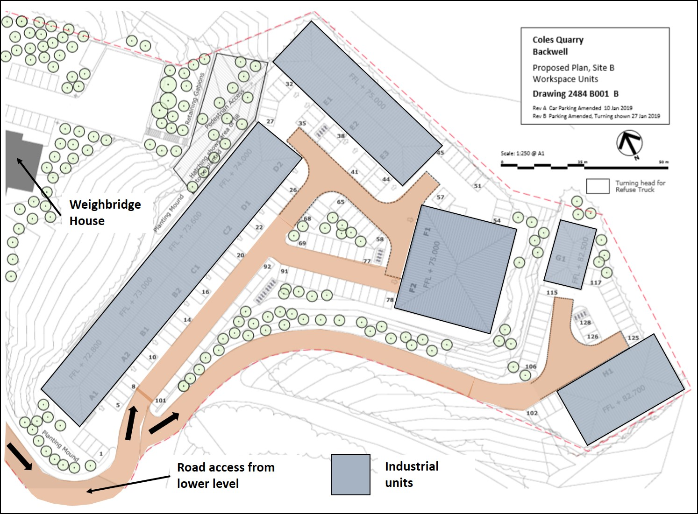

- The developers have had discussions with NSC and BPC concerning possible reorganisation (at the developer’s expense) of the Household Waste Recycling Centre (HWRC). Whilst Coles Quarry and the HWRC are close neighbours, and share a common entrance, it should be noted that the HWRC operation is a NSC activity on NSC owned land. The proposal is to change the route for vehicles within the centre. Users will drive to the far end of the site, do a U turn, and drive back with the skips on their left (rather than on their right as currently). One benefit is that cars will still be able to unload whilst servicing of the skips is carried out. Also, in busy times, there will be space for cars to queue within the site, but it is unclear whether this facility will be available prior to the tip opening to alleviate the problem of the public arriving early and queuing in Church Town. BRA is attempting to seek clarification on this point.

The proposed changes to the HWRC are given below:
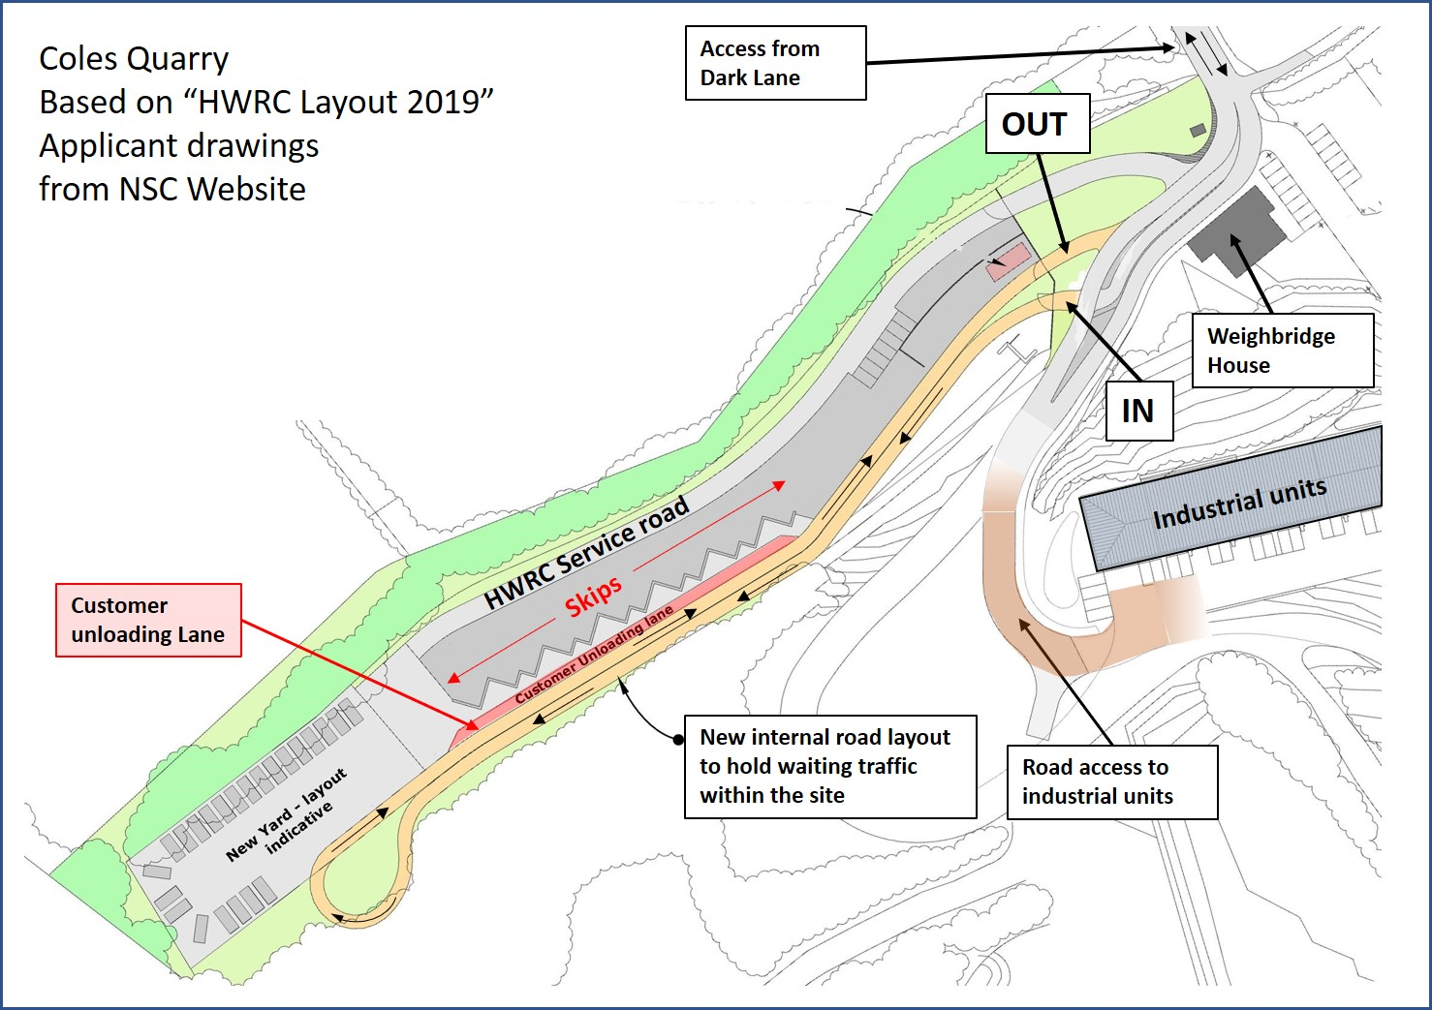

Dark Lane, Church Lane and Church Town have never been suitable for heavy traffic, even though they provided the access to a large working quarry and cement plant up until the 1980’s. In the 1951 census the population of Backwell was 2,003, and it grew to 4,589 by 2011, with further growth since. Despite the population more than doubling over this period, these roads are virtually unchanged and are narrow, with inadequate or non-existent pavements. Local residents would prefer no extra traffic from any industrial units to add to existing traffic including a busy Junior School and the Recycling Centre.

POINTS IN FAVOUR OF THE APPLICATION
- It will create local employment within Backwell, as proposed in the Neighbourhood Plan.
- It will bring derelict land into productive use.
- It will potentially improve the HWRC and access to it, and we understand NSC is attracted to the proposal.

POINTS AGAINST THE APPLICATION

- The new units will create more traffic in Dark Lane and more traffic congestion in the vicinity of the Junior school, in an already busy area. The developers have estimated, using standard factors, that the daily number of two-way vehicle movements caused by the development will increase from 362 under the approved 2014 application to 530 under the latest revision. We have yet to see the effect of even the lower figure of 362 vehicles per day as no units are yet operational.

BRA is disappointed to note that a report from NSC Highways and Transport dated, 26th Feb 2019, posted on the website states:
Highways are satisfied that the traffic generation associated with the proposed development will not result in significant increases in traffic volumes on the local highway network in the vicinity of the site when compared with the permitted lawful use of the site and will not result in detriment to the local highway operating conditions in this location.
We believe this not the view of local residents.
- The revised scheme will project further into the Green Belt, beyond the original Quarry plant footprint.
- BRA is of the view that the HWRC should not remain on this site in the long term and any perceived improvements under this scheme may make it less likely that NSC would consider re-locating it to a more suitable site in the future.
At the BRA AGM on Feb 12th, a straw poll of those members attending showed a rough balance between supporters and opponents of the application. We are aware however that some of those objecting to the application are passionately opposed to any increase in traffic.
CONDITIONS Even if the present application is approved, there is scope for NSC to apply conditions to the development. One key aspect is that of restrictions to the traffic e.g. a 20mph zone in Dark Lane, or Church Lane and Church Town. We are aware of strong feelings about 20mph zones, and their enforcement and of the pros and cons of speed bumps etc. BRA believes that the vast majority of people living near the Coles Quarry site would favour a 20mph speed limit.
NEXT STEPS
Please make your views on the amended application known to NSC by the closing date of Tuesday March 12th, even if you have previously commented on the original version. Comments may be made on the website
https://planning.n-somerset.gov.uk/online-applications/applicationDetails.do?activeTab=documents&keyVal=ZZZXGRLPJV009
using the “make a comment” button.
The BRA committee will discuss the application on Tuesday evening March 5th and we will email our conclusions in a second bulletin. If you comment to NSC before then, we would appreciate being copied in, to help inform our discussions. Our present feeling is that we will object, as we did to the original 2016 application.
Members may like to know that BPC is holding its next Council Meeting on Thurs March 7th at 7.30. The Coles Quarry application will be considered, also the possibility of extending 20mph limits. Members of the public may make a brief statement at the beginning of the meeting, and listen to the subsequent agenda items.

From your BRA Committee 1st March 2019

Visit our website on www.backwellresidents.org.uk
Email us at backwellresidents@btinternet.com

