BRA Bulletin 25.4.19

Joint Spatial Plan and Bus Timetable Changes

Dear Member

This bulletin covers two very different topics!

West of England Joint Spatial Plan (JSP)

The JSP has been the subject of several BRA bulletins in the past, the latest of which was the January Newsletter which we delivered to 2,000 households in Backwell and adjacent areas. We explained that the JSP had been created by four councils (Bristol City, Bath and North East Somerset, South Gloucestershire and North Somerset (NSC) known as “West of England”). The JSP allocates housing across this area up to 2036. Unfortunately, Backwell is one of 4 villages in the NSC area allocated a “new community” on its doorstep, with a proposal for 700 houses, and building starting in 2028. The land is around Grove Farm to the west of Backwell. We encouraged BRA members to comment. In the whole region, 4,800 comments were received and we understand that Backwell was well represented in this number. The fact that there is huge public opposition to the JSP proposals for Backwell is very significant.

The time for public comment has passed, and the focus of attention is now on the Examination of the JSP, which is a lengthy technical process. Public comments will be noted and play a big part, but much of the discussion will be on such matters as “Is the JSP “sound”, “robust”, “justified” and “effective”? Planning terms such as these have technical definitions.

The examination details can be found on www.hwa.uk.com/projects/west-of-england-joint-spatial-plan

The main features are:

- The examination will be chaired by 2 inspectors, Malcom Rivett and Steven Lee, supported by a programme officer, Helen Wilson.
- The Hearings will run from Tues July 2nd to Friday July 12th, followed by a summer break, and resume on Tues Sept 17th until Fri Oct 11th

Much of the discussion will be on general considerations e.g. habitat and transport.

However, in Sept the focus will be on specific locations.

On Tuesday 24th Sept, both am and pm slots will be devoted to Backwell.

- Hearings are confined to Tues-Thurs, with Fri reserved for any overrun items in the week.

4. The hearings will take place at the Future Inn Bristol, Bond St South (opposite Cabot Circus, not far from the Bristol Evening Post building)

5. The Inspectors will consider the technical aspects of the JSP. Backwell has the opportunity to make representations on these. BRA has combined with Backwell Parish Council (BPC), and Backwell Resistance (BR) in appointing Lucy White as our planning consultant. Lucy gave a presentation at the BRA AGM on Feb 12th 2019, is well qualified and a Backwell resident. These organisations are represented on the BPC Working Party thereby showing a united front. Consultancy costs are being shared. The Working party has also commissioned experts in roads and transport, and ecology.

6. Unlike the Farleigh Fields public inquiry, it is not likely that members of the public will be invited to speak, so our choice of consultants is crucial.

What should members do now?

- Please look at the JSP website www.jointplanningwofe.org.uk/ to refresh your memory of what the JSP says.

- You may like to have a look at the schematic map we sent out in the January Newsletter, reproduced below

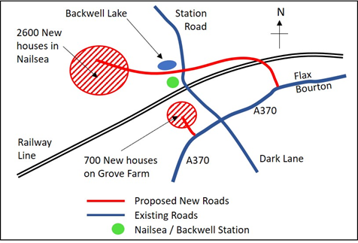

- Many thanks to the over 350 households who have paid their £10 membership subscription for 2019. If you have not renewed your BRA membership, we will shortly be sending out reminders. It is a huge help if Backwell can afford to pay for the best advice and representations at the hearings, and for our speakers to be able to quote our large membership numbers. This was a significant feature in our success in defending Farleigh Fields

D. Keep an eye open for future bulletins, which will appear between now and the start of the hearings.

Changes to Bus Timetables from Sun 28th April

First Bus timetables will change from Sun 28th April, and we thought you would like to be warned in advance as Backwell users will be affected. Bus routes will be changed, and also some frequencies, with a reduced Sunday service.

X1 is now our express bus along the A370, every 20 minutes, both towards Bristol and Weston

X2 still goes through Backwell between Bristol and Weston, but goes through all the villages - Long Ashton, Claverham, West Wick etc., and is far from an express route! It will not run on Sundays

X8 runs from Bristol to Nailsea via Backwell and is sadly reduced to an hourly service, and will not run on Sundays. It has a different route within Nailsea.

The X1X is a new express service from Bristol to Weston via Avonmouth and the M5! If you arrive at Bristol Bus station and get this bus, which says "Weston", you will not go via Backwell!!

The new timetables may be viewed on the First Group website:
https://www.firstgroup.com/bristol-bath-and-west/news-and-service-updates/planned-changes/28-april-service-change-north

Best wishes
From your BRA Committee 24th April 2019

Visit our website on www.backwellresidents.org.uk

Email us at backwellresidents@btinternet.com

1556135457410blob.jpg

