BRA Bulletin - July 17th 2019

JOINT SPATIAL PLAN (JSP)

The JSP process has taken a significant step forward, with the first section of hearings now completed at The Guildhall in Bath, having started on July 2nd.

Members may wish to refresh the main features of the JSP by looking at the BRA website under the JSP tab. The schematic below is a reminder of how the proposals would transform our village.

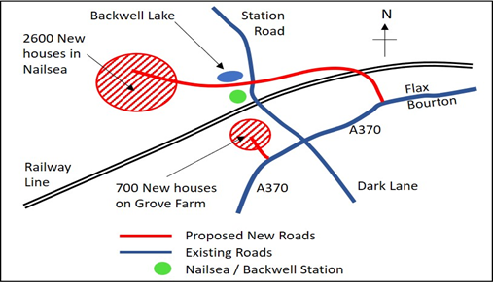
Three members of the BRA committee and the chairman of Backwell Parish Council attended the most relevant days for Backwell as observers.

The two Inspectors have reviewed hundreds of documents, and used the Hearings to listen to additional points submitted by participants, and to interrogate the Councils. At the beginning of the Hearings they said they have three options:

- to approve without modifications (highly unlikely)
- to approve with (potentially substantial) modifications
- to reject the Plan entirely

This first section (over two weeks) has mainly covered general principles, including the soundness and sustainability of the Plan, legal compliance, the overall number of new houses required, the spatial strategy and reliance upon Strategic Development Locations (SDL’s), and potential changes to the Green Belt. (Backwell has been chosen as one of the SDL’s)

The second section, which is due to take place in late September/early October will largely deal with assessing specific locations for development. The Backwell Hearing is provisionally down for 24 September (but this might change).
Those invited to speak at the Hearings include local councils, developers and pressure groups. Backwell (the Parish Council, BRA and Backwell Resistance have joined forces) has been represented by Lucy White (Planner) and Steve Holloway (ecologist). Lucy had a significant role in presenting our case and emphasised what we consider to be the significant flaws in the Plan, especially with regard to the potential Strategic Development Location (SDL) in Backwell. She made our case very powerfully. Our transport specialist will be called to speak at the September Hearing.

Specific issues that were discussed, and which we think have put serious questions into the minds of the Inspectors, include:

- The Plan has not considered all reasonable alternative options for growth.

- The SDL’s were selected first and the Spatial Strategy then built around them (the opposite of what should have happened!).

- It has not been made clear why the chosen SDL’s (12 sites) were selected out of the original long list of 40 sites. There appear to be inconsistencies in the assessment of sites.

- Employment growth and linking homes with employment was queried.

- North Somerset Council (NSC) made a policy decision (unlike the other three local authorities) not to touch Green Belt. This seems to be a political rather than a Planning decision. In addition, the strategic importance of Bristol Airport has not been recognized in the JSP.

- The JSP Habitat Regulation Assessment was not robust, risking harm to the protected habitat for bats.

- The public transport strategy was flawed, with unsubstantiated reliance on the proposed Backwell transport hub.

In summary, the Inspectors challenged the Councils on many aspects of the Plan, and will now write to the Councils setting out their initial conclusions and whether the Hearings in September/October can proceed as planned, or if an alternative course of action is required. The many objections from residents to the JSP were supported by the excellent planning arguments at the Hearings. The general feeling of the Backwell attendees is that we presented our case in the best way we could.

The funds input by Backwell Parish Council and BRA so far have been well spent.

Thank you

Firstly, a big thank you to the hundreds of residents who made their views on the JSP known by commenting last winter. These will be seen by the Inspectors as part of their compulsory reading in their big pile of documents! There is little public participation during the Hearings, but the Inspectors will be impressed by what they read. However, Inspectors will also be influenced by external factors e.g. from the national government. The outcome is still very uncertain.

Secondly, a big thank you to our members for re-joining BRA this year. Your subscriptions and donations enable us to fund appropriate technical support for this crucial time in the future of Backwell.

From your BRA Committee 17th July 2019

Visit our website on www.backwellresidents.org.uk

Email at backwellresidents@btinternet.com

