Backwell Residents Association
NEWSLETTER
January 2020
Please come to our AGM on Tuesday 25th February at 7pm
in the Sixth Form Lecture Theatre at Backwell School
Please pay your £10 membership now or at the AGM
(membership form on the back page)
All members and non- members are welcome to attend

We hope you find our Newsletter interesting. It is delivered to all Backwell households by our volunteers, and aims to bring you up to date on planning matters prior to our AGM, where you will be able to have your say. Membership of BRA has the advantage of regular email bulletins giving dates for making comments on planning applications, public exhibitions, details of road closures and other matters. We are pleased that so many members have provided us with an email address, which helps us keep in regular touch. Please also look at the BRA website, where there are tabs for all the main issues, with links to the many documents and letters we have written on them.

Our January 2019 Newsletter was dominated by the Joint Spatial Plan with large numbers of houses suggested for Backwell and Nailsea, and new roads that were largely unaffordable! The JSP is no more, but some very specific proposals are emerging in its place, pending some form of “JSP successor”. The much-changed North Somerset Council (NSC) will be tackling this issue, and will be considering the application to expand Bristol airport even further. NSC have declared a “Climate Emergency”.

Planning approval for the industrial units at Coles Quarry has finally been given, along with associated conditions. These and other matters not in this Newsletter will be mentioned at the AGM.

The photos below show two possible development areas which are described overleaf, and illustrate the loss of countryside we are facing.

65 Houses off Rodney Road? 700 houses on Grove Farm?
(seen from Chelvey Road)

Infant School Scout Hut Grove Farm Backwell Church
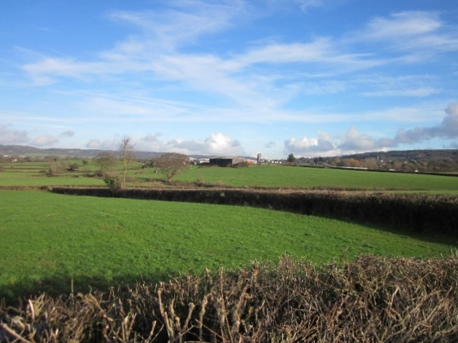
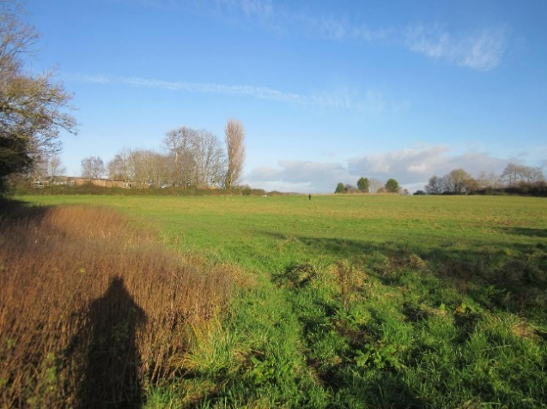

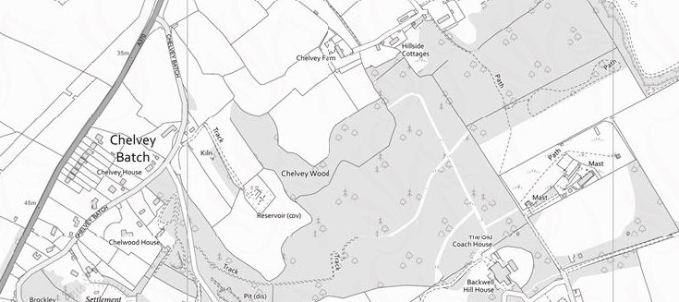
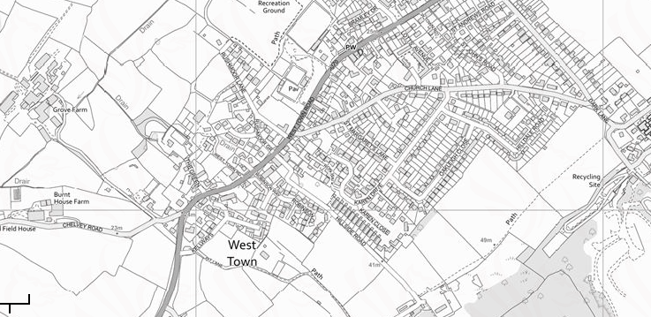
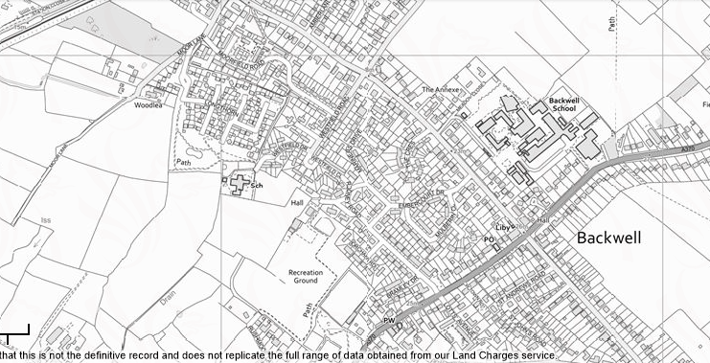
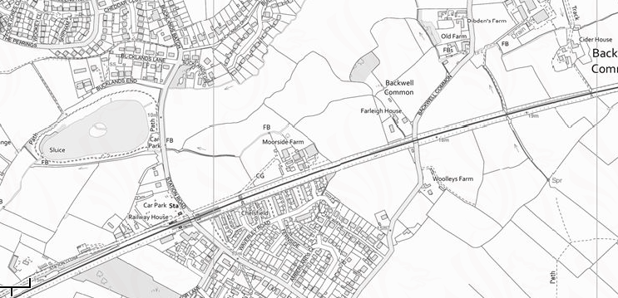
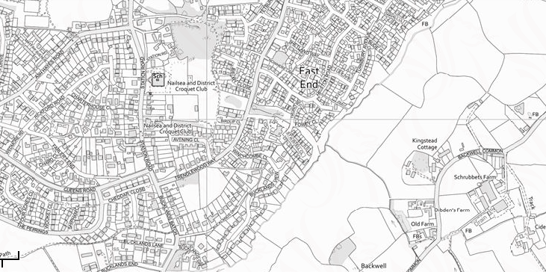
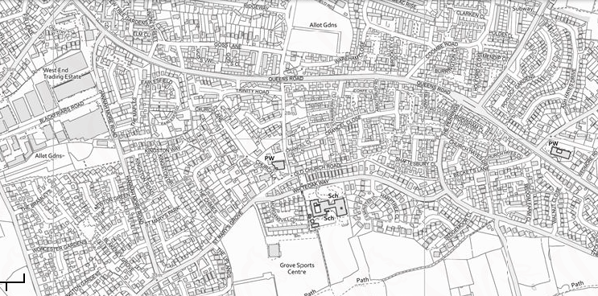
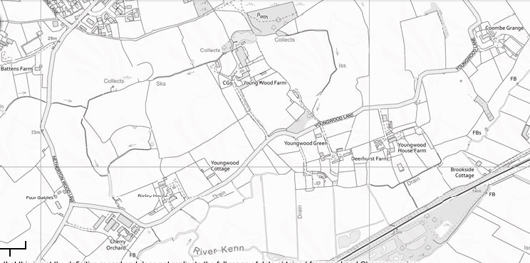
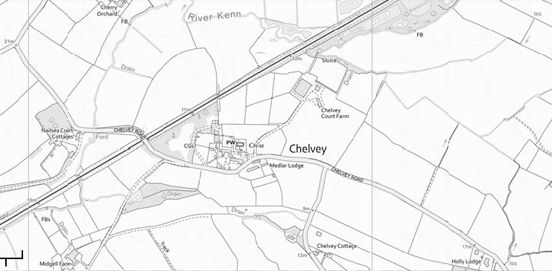
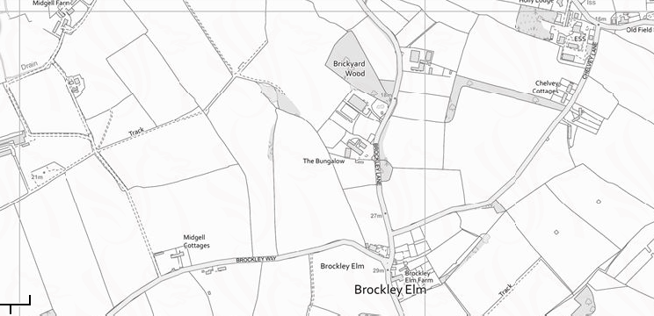
Ongoing & Potential Developments
3 Developments in Progress
2 Anticipated Applications
Approved Development
Village settlement boundaries
Youngwood Lane Houses
Rodney Road
Houses
Grove Farm Houses
Formerly Red Cross Hall & Ettrick Garage
Formerly
New Inn
Moor Lane Houses
Nailsea
Backwell
Lake
A370
A370
Rodney Road
Station Road
Chelvey Road
Youngwood Lane

Moor Lane (65 houses) (Ref 15/P/1916/O)
New Inn (9 houses) (Ref 17/P/0430/F)
Red Cross Hall (8 houses) (Ref 18/P/4269/MMA)

These 3 development areas are all in the Backwell Neighbourhood Plan and are all major building sites at present. Marketing for the Moor Lane houses has already started.

Youngwood Lane, Nailsea (450 houses) (Ref 16/P/1677/OT2)

This site is located to the north of Youngwood Lane just over the Backwell border, in Nailsea. Consent was granted in November 2019 for the development of 450 houses, by the Planning Inspectorate, after an Appeal against deemed refusal by NSC.

It is adjacent to the official Strategic Gap between Backwell and Nailsea, and development will remove pleasant fields and good quality agricultural land. It is a quiet area, well used by walkers and cyclists, and will be eclipsed by a development equivalent to 25% of Backwell’s current size. Equally disturbing is the Inspector’s view that road access to the site is “adequate”. The proposed access point is at the junction of Engine Lane with St Mary’s Grove. The only roads to the west and South are narrow country lanes, and the routes to the town centre and out towards Bristol or Backwell are already busy residential streets which will be further congested.

The clear suspicion – and this has implications for the Grove Farm site in Backwell - is that the Planners (NSC and/or the Planning Inspectorate) are driven by the perceived need to provide more homes in North Somerset, and this is overriding all other rational planning tests.

The possible developments below (in purple on the map) have yet to seek planning permission. Neither is within the Backwell Settlement Boundary, and neither site was identified in our Neighbourhood Plan.

Rodney Road Housing (65 houses) (on the field beside the Scout & Guide HQ) (see Taylor Wimpey website – “Rodney Road”)

Taylor Wimpey (TW) has consulted residents on its intention to apply for planning permission for 65 houses here, with the access being from Rodney Road. Little detail was forthcoming from TW at the public meeting held on Nov 21st 2019. The BRA committee is unanimously opposed to this development, principally on the grounds of traffic congestion and the vehicular access point, and will be asking members to object when an application is lodged.

Grove Farm (700 houses) (see Taylor Wimpey website – Grove Farm)

In 2017, Taylor Wimpey announced its intention to seek planning permission to build 700 houses on land surrounding Grove Farm. The Joint Spatial Plan (JSP) included exactly this number of houses in this extensive location. It was widely criticised by BRA, Backwell Parish Council (BPC) and hundreds of Backwell residents. Thankfully the Government Inspectors agreed with us and recommended withdrawal of the JSP in total. However, given the perceived need for housing in North Somerset, it is likely that whatever emerges from a revised planning process may well suggest a similar development.

A glance at the map opposite will show how the Youngwood Lane development will urbanise the large rural area between the edge of the Nailsea settlement boundary and the railway line. If housing off Rodney Road and on Grove Farm goes ahead, we too will lose much of the attractive countryside on our doorstep, and inadequate country lanes will be transformed into busy roads.

BRISTOL AIRPORT PLANNING APPLICATION (18/P/5118/OUT)

The BRA website has a tab dedicated to this topic with much background, including our bulletins of 9.1.19 and 30.11.19 which encouraged members to comment on the application to expand the airport to 12million(m) passengers pa. Many of you did, along with residents from elsewhere. In Jan 2019, your committee felt it could not support the application, but took a neutral stance. Since then, we decided to test our members’ opinion with a survey. We had a response from 204 households, which is 46% of our membership. Of these, 86% objected to the application, 4% supported it and 10% were neutral. Issues mentioned by members included noise, traffic and parking, inadequate roads, air quality, pollution and the environment, with encroachment into greenbelt resulting in the permanent loss of habitat.

Following this result, as well as further research, including attending meetings with other villages, we have revised our position from being neutral to objecting. Our letter of objection (2.1.2020) is posted on our BRA website. Bristol Airport already has permission to expand from its current 8m passengers a year to 10m, a 25% increase. BRA’s response seeks to halt further expansion beyond 10m, but NOT to demand a decrease in passenger numbers from the current level, or to prevent the already approved expansion.

This application is due to be discussed and voted upon at the NSC Planning and Regulatory Committee meeting on Monday 10 February (6 pm at Weston Town Hall). The meeting is open to anyone who wishes to attend.

20 MPH LIMITS

NSC has confirmed its intention to install a 20mph speed limit throughout the whole village of Backwell (except for A370 road) by the end of this year. The limit will be controlled by signage rather than speed bumps. Further information may be available by the time of the AGM. Although 20mph limits generate polarised opinions, the BRA committee supports BPC’s intentions to improve road safety by addressing this issue.

COMMUNITY INFRASTRUCTURE LEVY

The Community Infrastructure Levy (CIL) is a new way of receiving funds from developers in return for the granting of Planning Permission. It is in addition to the well-established Section 106 Agreements.

The Planning Authority (in our case North Somerset Council) has overall responsibility for managing CIL but Government guidance makes it clear that Parish Councils should have a significant say, and they in turn should involve the local community in identifying appropriate projects/activities where funding can be justified.

Guidelines for permitted projects can be seen on-line by searching “NSC CIL” which shows what money can be spent on. For example, seating areas, footpaths, play areas, youth activities, and for larger sums – parking, and improvements in highways are allowed. Even a small development could yield several thousand pounds for Backwell to spend on suitable projects.

BRA is discussing with the Parish Council how and when individuals, clubs and local groups can contribute ideas into how Backwell could benefit from this levy. We will be providing further information in due course.

BACKWELL RESIDENTS’ ASSSOCIATION

This year’s ANNUAL GENERAL MEETING will be held at 7.00pm on Tuesday 25th February 2020 in the Sixth Form Lecture Theatre at Backwell School (entrance via Meadow Close off Station Road)

AGENDA
- Apologies for Absence
- Approval of 2019 AGM Minutes (available on website or on request to Hon. Sec.)
- Chairman’s Report
- Membership Report
- Honorary Treasurer’s Report and Audited Accounts for year to 31 Dec 2019.
- Election of Officers* Honorary Secretary, Honorary Treasurer and up to five Committee Members. The following Nominations have been made at the date of this Notice:

Hon Secretary | Mike Veal | Proposed | Judy Thomas | Seconded | Geoff Wells
Hon Treasurer | Kevin Crawford | Proposed | Sue Ivens | Seconded | Keith Riches
Committee Member | Barbara Harland | Proposed | Mike Rose | Seconded | Mike Veal

The following Committee Members, having served three years are retiring at the Annual General Meeting and offer themselves for re-election.

Committee Member | Gillian Collison | Proposed | Valerie Wells | Seconded | Sue Veal
Committee Member | Chris Elliott | Proposed | Ted Smallbone | Seconded | Bill Charnock
Committee Member | Two vacancies*

- Appointment of Auditor:

Auditor | Richard Gaunt | Proposed | Keith Riches | Seconded | Terry Merrett-Smith

- Any Other Formal Business
- Guest Speaker and Open Forum

*Nominations for the Committee vacancies should be made to the Honorary Secretary, 36 Longthorn, Backwell, BS48 3GY at least 24 hours in advance of the Meeting. Nominations must be proposed and seconded by members in full membership for not less than three months prior to the Annual General Meeting and signify the nominee’s willingness to serve.

Members are reminded that the Committee has authority to co-opt additional members as necessary to undertake specific roles. We are particularly interested in recruiting a Committee member with knowledge or experience of planning law and procedures. Please contact the Chairman or Secretary if you would like to discuss this possibility.

NB The Meeting is open to all Backwell residents but only paid up members may vote or make nominations. The formal aspects of the AGM will be kept to a minimum so that we can devote most of the time to the matters covered in the attached newsletter and other matters raised by members.

Current Elected Committee Members:

COLLINSON, Gill - (Recruitment)
CRAWFORD, Kevin - (Treasurer)
ELLIOTT, Chris
KEMP, Margaret - (Membership & Web Manager)
MERRETT- SMITH, Terry - (Asst. Treasurer)
RIBBON-MILES, Angela - (Social Media)
RICHES, Keith - (Chairman) - 462908
ROSE, Mike - (Planning Specialist)
VEAL, Mike - (Secretary) - 461187
WELLS, Geoff - (Publicity Manager) - 462627
WELLS, Valerie - (Recruitment) – 462627

Current Co-opted Committee Members:

HARLAND, Barbara – (Airport Liaison)
STEWART, Bruce - (former Chair and Secretary)
VEAL, Sue - (Minutes Secretary)

The BRA Committee is mindful of the fact that we are a membership organisation, and that often a planning application will have both positive and negative aspects. We welcome comments from our members at any time. We look forward to welcoming our members and non-member residents to our AGM. Over 440 Backwell households with nearly 800 adult members paid subscriptions for the period to 31 December 2019. Renewal subscriptions of £10 per household are now due to cover the year to 31 December 2020. A membership application / renewal form is attached and we hope that you will join or re-join to strengthen our representation and increase our funds upon which there are likely to be heavy demands this year in protecting our village from over-development.

Visit our website at www.backwellresidents.org.uk
E-mail us at backwellresidents@btinternet.com

27th January 2020

Backwell Residents Association Membership Form
Period up to December 31st 2020

I / We would like to (re-) join Backwell Residents Association.

Forename: Surname:
Forename: Surname:

Address: …………………………………………………………………………………………………….

Post Code: …………...…….… Telephone: …………...………………...………………...…...

Email: …………………………………………………………………………………………...……........

Please supply an email address if at all possible. Our main distribution method is by email bulletins, which are fast and cost nothing. Newsletters are much less frequent.

Membership Subscription £10 per household per year
(gives votes for all household members aged 18 and over) £ 10

I / We wish to make an additional, optional donation to BRA £____

(Cash / Cheque payable to Backwell Residents Association)

TOTAL £____

Signed: ……………………………………….…………………... Date: ……………………………...

Help is welcome with deliveries, BRA admin, IT skills, other specialism etc.
Please state below if you would like to offer assistance

………………………………………………………………………………………………………………

Please return this form and money to the BRA drop box inside the Post Office or to Terry Merrett-Smith, 29, Rodney Road, Mike Veal, 36 Long Thorn, Valerie Wells, 8 Bramley Drive, or to any other BRA committee member.

Or renew by electronic transfer to: Nat West sort code 60-14-49,
Account No 05005531 giving your surname, house number and street. Please also email us on backwellresidents@btinternet.com to add or confirm your contact details on our membership list. Better still please set up an electronic annual standing order.

Visit our website at www.backwellresidents.org.uk . This is kept up to date with all our communications, links to other websites etc. It is a valuable resource.

Backwell Residents Association Objectives - BRA will work to safeguard and promote the collective interests of Backwell residents in matters concerning social, economic and community life and the character of the village.

The Association will support or oppose development affecting Backwell having regard to residents’ interests and the local environment.

GENERAL DATA PROTECTION and PRIVACY REGULATIONS (GDPR) The details you supply on this membership form will be kept on the BRA database and used for internal admin purposes and will not be shared with any other organisation. It will be used to keep you informed by bulletins and newsletters on matters in furtherance of BRA objectives. By joining BRA, you give permission for us to store your information and you agree to BRA sending you information to your address, or to your email or (exceptionally) by phone. You may contact us at any time to cancel this arrangement. BRA abides by the principles of the GDPR, and will maintain the security and privacy of your personal information

