Backwell Residents Association
NEWSLETTER
April 2021

Welcome to BRA’s 2021 Newsletter which we deliver to our whole village of around 1,950 households to highlight issues that are relevant to Backwell residents. This year our newsletter has been delayed from January by the pandemic, but we hope you will find it interesting.

Backwell continues to be a supportive community, with many individuals and organisations doing their best to help those most affected by Covid. The lockdown has given us the opportunity to explore our lovely local area and countryside, reconnect with nature and use our fantastic footpaths.

The skies and roads have been strangely quiet for the past year, but the same cannot be said of planning issues! Developers and North Somerset Council (NSC) have both been very active with planning applications, along with a steady stream of consultations, including those for the North Somerset Local Plan.

This Newsletter covers many topics, but much more is available on our website
www.backwellresidents.org.uk including links to planning applications, and letters that BRA has sent to NSC, making our case. Additionally, we keep members informed with frequent email bulletins during the year.

RODNEY ROAD HOUSING (the photo shows our rare strawberry and cream tree in Rodney Road, which now has a tree preservation order on it).

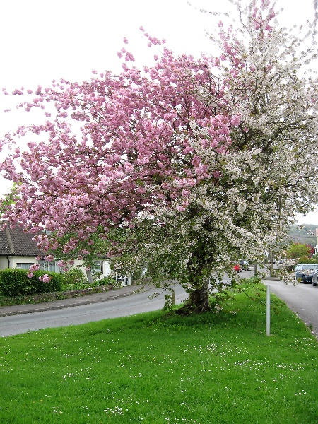
There is still no decision on this planning application by Taylor Wimpey to build 65 houses on this field, adjoining the Playing Fields. Over 350 public comments were submitted last year, almost all objecting to the scheme. The BRA Committee used members’ funds to commission strong letters of objection from two professional advisers who identified serious weaknesses in the application. Objections principally relate to the inadequate access into the site which will cause serious safety issues, and the impact on inadequate roads serving the site. The area is popular with walkers, and is heavily used by school children and by 200 members of the Scout Group each week.

The NSC Ecology Officer has raised significant concerns about damage to the environment and to the local bat population. We are led to believe that an environmental survey over an extensive period, including this summer, will be required to respond to these concerns. It seems unlikely any decision on this application will be made until the Autumn.

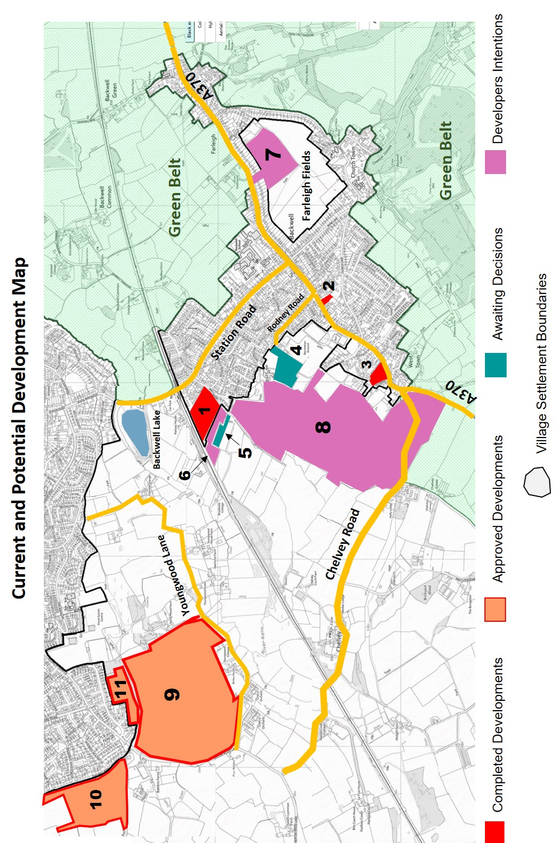

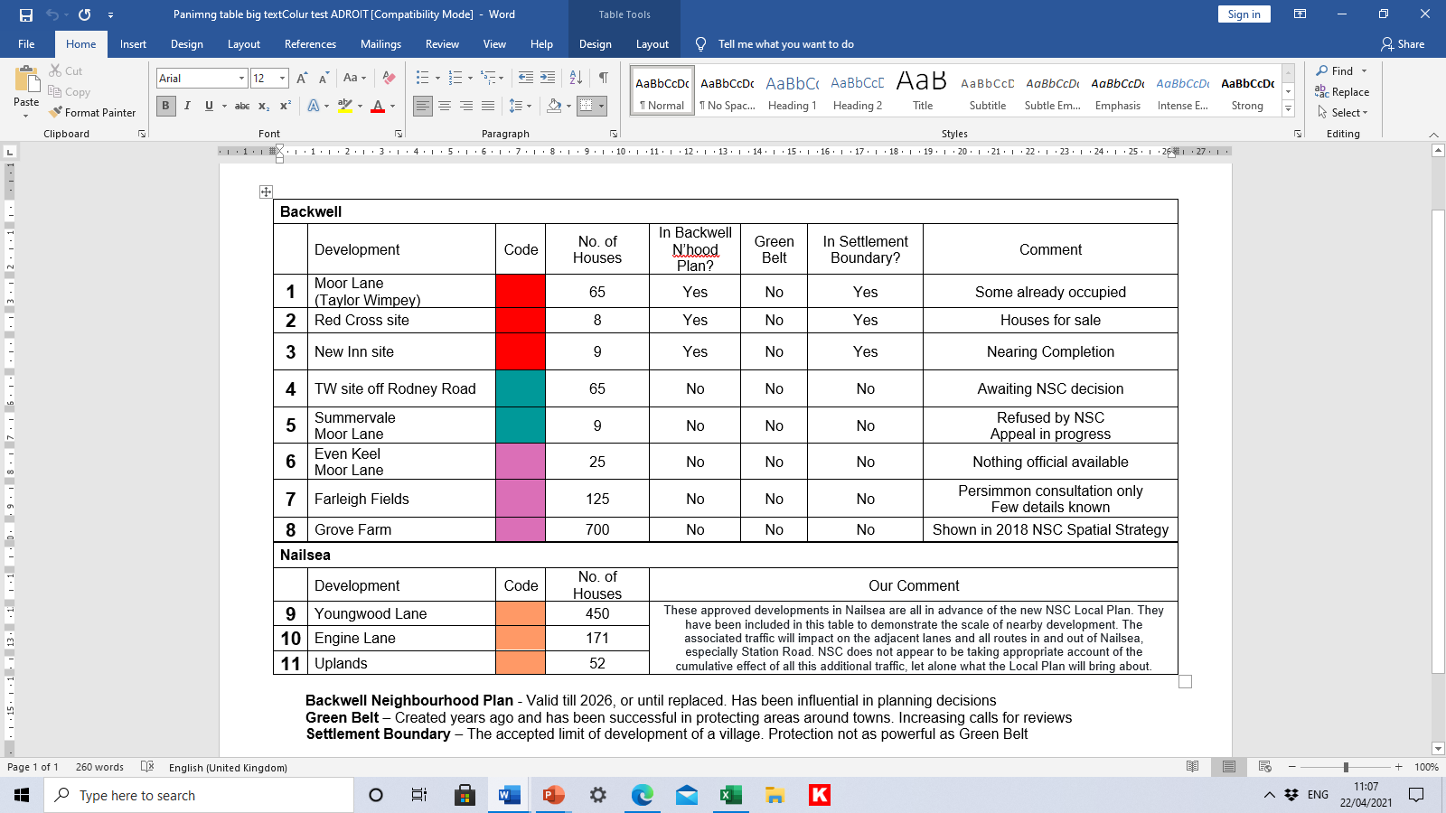
UPDATE ON NORTH SOMERSET LOCAL PLAN

NSC is progressing the laborious process of producing a new Local Plan (for development) – which will be in place until 2038.

In 2020 NSC conducted two consultations - "Challenges “and "Choices", asking residents to provide input - and we are grateful that many of our members took time to contribute.
The results are fully explained on NSC’s website, and include a marginal preference for our preferred option of "Urban Focus". This proposes that most new development will take place in the main towns of our region - although it is clear Backwell will also be expected to absorb a number of new dwellings.

Following this consultation, NSC is formulating a "preferred spatial strategy" for the new Local Plan -and we expect further information and consultation on this process during the summer.

FARLEIGH FIELDS

Unfortunately, the owners of Farleigh Fields, Persimmon plc, have chosen to reactivate their development aspirations for this land. There is a long history of their attempts to build on this land, going back to the 1980’s, all of which have failed. It was only 4 years ago in March 2017 that members of Backwell Parish Council and BRA, with our advisers, endured the long and expensive, but finally successful, Inquiry at Weston. Backwell expressed its views with 350 residents opposing the housing, and 3 in favour. The findings, in a letter from the Secretary of State in March 2018, concluded that the development (of 220 homes on this occasion) would have an urbanising impact on Backwell, and there would be “significant harm to the character and appearance of the area”.

Persimmon has started a public consultation with a leaflet drop to present their latest proposal for 125 dwellings. They propose to seek planning permission to build houses in the field at the east end of the site next to Fairfield School – with access onto the A370 through a property which they will demolish on Farleigh Road.

We will let members know when the time comes to respond to any planning application.

RECYCLING CENTRE

The Recycling Centre in Backwell is one of three operated by NSC. The others are at Weston-super-Mare and Portishead. Over the years there have been many difficulties and NSC, the Parish Council, BRA and affected residents have worked together to try to lessen the most troublesome issues. Recently traffic queues have often become a major inconvenience, both to users and local residents. The catchment area for this facility is very wide and is getting ever busier. BRA believes that recycling centres should not be located in residential areas, but should be located close to the highest concentration of users. Backwell’s recycling centre does not meet these criteria, so we think, in spite of its convenient location for our residents, it should be moved elsewhere, and the NSC owned site should be made available for new houses. Your views would be welcome.

CLIMATE AND NATURE EMERGENCY

BRA fully supports NSC’s declaration of the Climate and Nature Emergency and our Parish Council’s recent declaration of intent to do all it can to deal with climate and nature change. BRA intends to put these at the heart of its comments on planning applications and all other relevant actions.

BRISTOL AIRPORT

In spite of the global pandemic, it has been a busy year for airport issues, even though there has been a huge reduction in flight numbers. Many of the issues associated with the Airport are very complex, and BRA has benefited from contact with The Parish Councils Airport Association (PCAA). This is an independent organisation representing 30 parish councils, including Backwell, enabling the sharing of information and costs and having a powerful voice on common interests.

The Planning Application and the Appeal

BRA recognises the benefits of the airport, but objects to the further expansion due to environmental and traffic issues. In March 2020, NSC refused the application by the Airport to expand from its current limit of 10 million passengers per annum up to 12 mppa. Further expansion was refused on environmental grounds in the light of the Climate Emergency. The Airport has subsequently appealed against this decision.

Government Inspectors will hear the Appeal starting on 16th July 2021 and has assigned 40 days. The Airport’s compulsory purchase order (CPO) of land at the A38 Lulsgate Bottom and Downside will be heard at the same time.

Other Initiatives

There are three other important issues: a new “Transport Interchange”, a Civil Aviation Review, and an application by the Airport for Fully Coordinated status. These could have an impact on the encroachment into the Green Belt, night flights, and flight paths. We will keep members informed.

RURAL LANES

On 31 March, NSC surprised residents by proposing a new Traffic Regulation Order to prohibit the use of motor vehicles (with exemptions) along many of our local lanes. There was a large public reaction to this news, with criticism of the undue haste, and lack of detailed information. On 7 April NSC withdrew the proposals, to provide residents and road users with “more opportunities to help shape the quiet rural lanes proposals”

BRA will watch this situation closely and keep members informed. The effort taken by many people to make their views known is much appreciated.

MOOR LANE

The Taylor Wimpey development of 65 houses, called Coppice Place, is under construction, with some houses occupied and others yet to be built. An application for 9 dwellings to be built on the Summervale site, just before the lane approaches the open fields, was refused by NSC and has gone to appeal. We understand also that an application for 25 dwellings on an adjacent plot, Even Keel, may be made. The width of Moor Lane and the junction with Station Road are serious traffic issues.

2021 Annual General Meeting

This was held on a virtual basis on Tuesday 23 February and was confined mainly to the brief formalities required to conform to our Constitution as follows: -
- The Minutes of the 2020 AGM were approved.
- The Audited Accounts for the year to 31 December 2020 were approved.
- The Secretary - Mike Veal, Treasurer - Kevin Crawford and Auditor - Richard Gaunt were all re-elected.
A small number of members joined the virtual Meeting and a short question and answer followed the formal proceedings. A summary can be viewed on our website.

The current BRA Committee is as follows: -

Elected Members: -
COLLINSON, Gill – (Recruitment)
CRAWFORD, Kevin – (Treasurer)
ELLIOTT, Chris – (Projects and Meeting Co-ordinator)
HARLAND, Barbara – (Airport, Traffic and Recycling)
KEMP, Margaret – (Membership & Web Manager)
MERRETT- SMITH, Terry – (Asst. Treasurer)
RIBBON-MILES, Angela – (Social Media)
RICHES, Keith – (Chairman) – 462908
ROSE, Mike – (Planning Specialist)
VEAL, Mike – (Secretary) - 461187
WELLS, Geoff – (Publicity and Communications) - 462627
WELLS, Valerie – (Recruitment) - 462627

Co-opted Members: -
HESLOP, Sally – (Sustainability and the Environment)
STEWART, Bruce – (former Chair and Secretary)
VEAL, Sue – (Minutes Secretary)

MEMBERSHIP

The BRA Committee is mindful of the fact that we are a membership organisation, and that often a planning application will have both positive and negative aspects. We welcome comments from our members on planning other issues at any time. Over 400 Backwell households, with more than 700 adults, paid subscriptions for the period to 31 December 2020. We are very grateful to those members who have already paid their £10 subscription for the current year, and encourage others to join or re-join as soon as possible if you have not already done so. This will strengthen our representation and increase our funds. It is already apparent that there will be heavy demands this year in protecting our village from over-development, as well as other issues.

A membership application form is attached.

Visit our website at www.backwellresidents.org.uk
E-mail us at backwellresidents@btinternet.com

Backwell Residents Association Membership Form
Period up to Dec 31st 2021

I / We would like to (re-)join Backwell Residents Association.

Forename: Surname:

Forename: Surname:

Address: …………………………………………………………………………………………

Post Code: …………...…….… Telephone: …………...………………...………………......

Email: …………………………………………………………………………………………….

Please supply an email address if at all possible. Our main distribution method is by email bulletins, which are fast and cost nothing. Newsletters are much less frequent.

Membership Subscription £10 per household per year
(gives votes for all household members aged 18 and over) £ 10

I / We wish to make an additional, optional donation to BRA

(Cash / Cheque payable to Backwell Residents Association) £ ___

TOTAL £ ___

Signed: ………………………………….…………………... Date: ……………………………...

Help is welcome with deliveries, BRA admin, IT skills, other specialism etc.
Please state below if you would like to offer assistance

…………………………………………………………………………………………………………

Please return this form and money to the BRA drop box inside the Post Office or to Terry Merrett-Smith, 29, Rodney Road, Mike Veal, 36 LongThorn, Valerie Wells, 8 Bramley Drive, or to any other BRA committee member.

Or renew by electronic transfer to Backwell Residents Association: Nat West sort code 60-14-49, Account No 05005531 giving your surname, house number and street. Please also email us on backwellresidents@btinternet.com to add or confirm your contact details on our membership list. Better still please set up an electronic annual standing order.

Visit our website at www.backwellresidents.org.uk. This is kept up to date with all our communications, links to other websites etc. It is a valuable resource.

Backwell Residents Association Objectives - BRA will work to safeguard and promote the collective interests of Backwell residents in matters concerning social, economic and community life and the character of the village. The Association will support or oppose development affecting Backwell having regard to residents’ interests and the local environment.

GENERAL DATA PROTECTION and PRIVACY REGULATIONS (GDPR) The details you supply on this membership form will be kept on the BRA database and used for internal admin purposes and will not be shared with any other organisation. It will be used to keep you informed by bulletins and newsletters on matters in furtherance of BRA objectives. By joining BRA you give permission for us to store your information and you agree to BRA sending you information to your address, or to your email or (exceptionally) by phone. You may contact us at any time to cancel this arrangement. BRA abides by the principles of the GDPR, and will maintain the security and privacy of your personal information.

