BRA AGM 2022 APPENDIX 2
PLANNING ISSUES - MIKE ROSE
Good evening. Lucy has been explaining what the future potentially has in store.
! am now going to provide an update on various planning and development issues in the village in the last 12 months or so.

Slide 1 - Most of you will remember the Backwell Neighbourhood Plan – approved in 2015. This proposed a modest amount of housing development on 3 main sites in the village. All three have now been developed. The land behind the New Inn - as was - has been developed with two small houses converted from the old pub building, and 6 large houses to the rear – ALL now completed and sold - for some eye watering prices!
On the site of the old Ettrick Garage and Red Cross Hall in the centre of the village has been built a terrace of 8 small houses - named Moody’s Leigh -after an orchard previously on the site. All are now occupied, one sold and the remainder let. Sales were not readily forthcoming, probably because the site is now rather crammed, and the houses were too expensive for many potential down-sizers (who would have liked to live in such a convenient location).
Coppice Place, in Moor Lane is the Taylor Wimpey development of 65 houses – all now completed, and the vast majority sold – quite an achievement having been developed during covid and lockdown.
So – in summary – a demonstration of the attractiveness of Backwell to many people at a variety of times in their lives. However, it also suggests that a modest growth in numbers –

i.e. 80 – 90 over a 7 or 8 year period is something the village can absorb and benefit from. Any faster or larger rate could present problems of infrastructure and services.

Slide 2 – As well as residential sites we also have two significant industrial sites in the village – but with very contrasting fortunes. Coles Quarry was proposed for development in 2015. After a chequered planning process, consent was finally granted in 2017 for a number of small industrial units and the conversion of the old weighbridge house. This latter was completed over 3 years ago and comprises a potentially very functional office premises - but is still completely empty. Adjoining, the developers have constructed a road up into the lower quarry – but nothing else has happened! The marketing of the site has only been very half-hearted and the quoted prices very expensive. It is currently very unclear what plans the owners have for this desperately under-used site.
In contrast – a little further up the hill is Cheston Combe – the previous site of the re-cycling centre. This has been developed with a number of units and is now the home for 15 different businesses – 10 of which are food related, and include Backwell’s own gin factory! A thriving site – much of which is down to competitively priced accommodation and local entrepreneurship.

Slide 3 – There are several potential new residential sites in the village. This slide shows what we are calling Rodney Road field – it sits between the Scout Hut and West Leigh School. Taylor Wimpey submitted an outline application for 65 houses early last year, and the application still sits in North Somerset’s offices, undecided. BRA, and many of you here strongly objected to the application – principally because of its poor and dangerous access and the implications on traffic in the Rodney Road area. North Somerset are still awaiting more detail from the developer on some ecological and highway issues - but it is suspected that – as the site is now included in the potential Local Plan sites for development - that Taylor Wimpey are holding back pending further feedback on the Local Plan. BRA intends to continue vigorously opposing this application and has been using two expert consultants to advise us.

Slide 4 – This slide shows the Farleigh Fields. Members will be familiar with the history – 4 previous attempts by developer Persimmon to obtain consent – all ending in failure. After a fifth application early last year on one of the lower fields, for 125 houses, the application was refused and the developer appealed. This Appeal was heard in the last few weeks – and many thanks must go to the dozen or so members who bravely made witness statements. This followed over 800 objectors to the application, including a professionally authored objection by BRA.
At the Appeal the developers made strong attempt to rubbish NSC’s view that they could provide the Government required 5 year land supply, and also sought to dismiss local claims that the unique character of Farleigh Fields would be destroyed, even by a very modest development. The result of the Appeal is not likely to be known for a few weeks yet.
It needs to be noted that, if the Appeal succeeds, and Persimmon get their consent for 115 houses, this would be in addition to any sites allocated in the Local Plan. Another point to watch out for is that Persimmon has offered to sell the two Local Green Space fields to the Parish Council for £1 -quite a tricky decision for the Council to decide upon!

Slide 5 – Two other residential sites - shown on this slide - should also be noted. Firstly – a site in Moor Lane adjoining Coppice Place. A local developer has just submitted an application for 55 small houses. There is no question that Backwell could benefit from some more small homes for first time buyers etc. However, BRA considers the developer in this case has been far too greedy, and applied for too many houses for the size of the site, and to cope with the very narrow access and route out onto the junction with the very busy Station Road. We encourage members to object likewise.
The second site is much more remote - on the site of the old BT Research Centre at the top of the hill overlooking the village. Planning consent has been granted for 5 large houses on this site - one of very few brownfield sites in Backwell. The owners are seeking to sell individual sites rather than build speculatively, and the prices quoted suggest very large, million pound houses – albeit in this very remote and inaccessible location.

Slide 6 – You can hardly have failed to notice a major feature in the last few years in the village – the number of house conversions - with or without planning permission - usually turning 2 and 3 bedroom homes into 4 , 5 or 6 bedroom homes.
Good news for building contractors!. Good news for young families moving into the village, attracted by good schools and plentiful services. But - NOT good news for those buyers looking to down-size or buy small affordable homes.
Too many such conversions are probably not good for the village, but, realistically, there is little which can be done to deter market demand.

Slide 7 - This slide shows both Backwell and Nailsea – and gives an indication of the amount of development currently underway in Nailsea as well as potential future sites. It is a sad fact that current planning law requires a Planning Authority to only consider the specific possible traffic congestion effects of a development, but, CRUCIALLY, not to consider the CUMULATIVE effects of traffic created by several nearby but different developments.
Realistically there are only two ways out of Nailsea to the east and south – either through Wraxall or Backwell. We are already seeing the effects with Station Road becoming more and more congested. Any future development in Nailsea MUST somehow make allowances for improved road infrastructure.

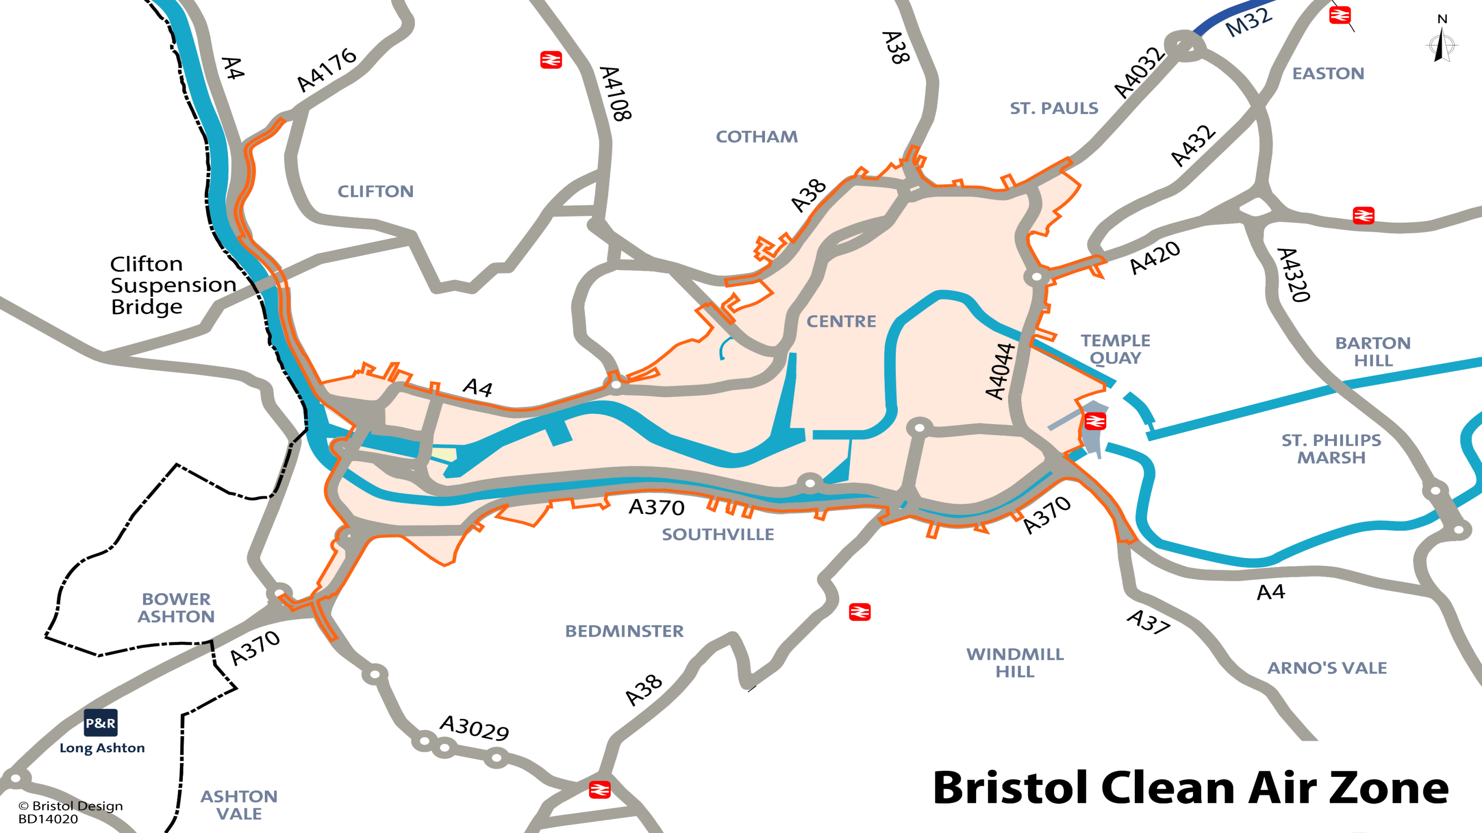
Slide 8 – Moving away from Backwell - this last slide refers to the imminent imposition of a Clean Air Zone in Bristol. Whilst the principles of this are laudable and we at BRA fully support the concept -there are some important drawbacks to be aware of. BRA has taken these up with our MP and the City Council, but has been ignored. Anyone who has a vehicle which does not comply with the permitted level of emissions will face a £9 charge to drive through the city centre. AND, crucially, this includes the Cumberland Basin. Anyone travelling north or east will either get caught or will have to use narrow and potentially over-crowded lanes to get across to the motorway. And this also applies to those travelling from the north and west down to Backwell and North Somerset - for example – the many Welsh residents seeking to drive to Bristol Airport.
There are some exceptions to the charging. We urge everyone to check online to see if their vehicle falls under the minimum target, and also check on line to see what exceptions are available – e.g. visiting hospital.
That concludes my whistle-stop tour. You can see there is a lot going on! Whilst BRA seeks to do its little bit to protect our village - I hope you will note from Lucy’s talk that we are NOT anti -development per se - instead we just want to encourage sensible and moderate growth of the right size and specification, with appropriate infrastructure to support it:
A very big ask - but this is our aim!

