BRA Bulletin 27.9.20 - this bulletin is attached as a pdf, for those wishing to print a hard copy

Dear Member

APPLICATION TO BUILD 65 HOUSES OFF RODNEY ROAD (Ref 20/P/1847/OUT)

This application has received 324 comments against the proposal, and only 2 in favour. BRA made its submission to NSC, with help from our Planning Consultant, Lucy White, who has spoken at our recent AGMs. In view of the importance of transport issues in this location, we have also employed Paul Lacey, who is well qualified on these matters. He prepared a separate transport paper which was sent alongside our letter. Both of these can be seen on the BRA website under “Taylor Wimpey Housing Proposals”, on this link: http://www.backwellresidents.org.uk/taylor-wimpey-housing-proposals/

We think that our submission is comprehensive and professional, and that these experts have guided us to make the points most likely to maximise our wish that NSC will refuse the application. We believe that our members will agree that paying for this advice has been a good use of BRA funds.

BRISTOL AIRPORT - COMPULSORY PURCHASE ORDER (CPO)

On September 15th 2020, Bristol Airport made an application for the compulsory purchase of land on both sides of the A38 at Lulsgate Bottom. This process is technical and complex, with the application going to the Sec of State for Transport. Comments are required by 16th October 2020.

A summary of the application can be viewed on the website below, which has links to the detail of the application.

https://www.bristolairport.co.uk/CPO

The CPO is a parallel process to the application by the Airport for an expansion from 10mppa to 12mppa which was refused by NSC earlier this year, and which is now the subject of an appeal.

Bristol Airport Limited (BAL) is obviously hoping that the refusal will be overturned on appeal, because the CPO states:
"The Order is required to support BAL's planned increase in the permitted passenger cap at the Bristol Airport from 10 million passengers per annum (mppa) to 12 mppa, which is the subject of an appeal against the refusal of planning application (reference 18/P/5118/OUT). "

A clear majority of BRA members are opposed to the 12mppa expansion. However, this area of the A38 is regularly congested and any improvements in the road junctions would be welcomed by some people. It is unusual to do this under a CPO by an independent body, and raises serious questions and the need for assurances as to the future of this highway. The CPO is premature, given that the new North Somerset Local Plan, and the associated infrastructure transport plan, are still in progress, and the outcome of the appeal for the expansion to 12mppa is awaited. Downside residents are anxious about the implications of this CPO, with maybe further CPO applications if this is seen as a precedent.
LAND INVOLVED IN CPO (source: Bristol Airport Application)

The areas of land are shown in red and numbered for reference in their detailed submission
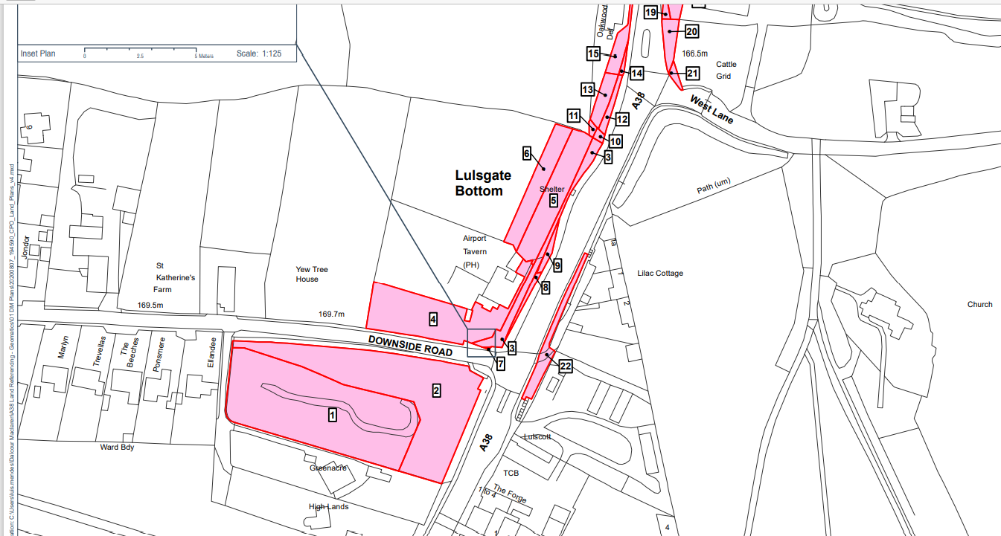

BRA is seeking advice and will respond with a strong objection before the deadline. Individuals may of course comment directly if they wish by writing to the Secretary of State for Transport, Aviation Policy & Reform, Zone 1/25, Great Minster House, 33 Horseferry Road, London, SW1P 4DR before 16 October 2020 quoting the following reference:
“THE BRISTOL AIRPORT LIMITED (LAND AT A38 AND DOWNSIDE ROAD) COMPULSORY PURCHASE ORDER 2020”
with the grounds of objection and the objector's address and interests in the land. There does not appear to be a route for an email response.

RECYCLING AND WASTE SERVICES

At a meeting in the past week, NSC decided to end its current commercial contract with BIFFA and replace it with a wholly council-owned company to run the services from April next year. More details are given in the link below:

https://www.n-somerset.gov.uk/news/recycling-waste-services-return-council-operation

NSC is working to ensure there will be a smooth transition, including transfer of staff, and there will be no immediate changes to the service following the change.

Best wishes
From your BRA Committee 27th September 2020

Visit our website on www.backwellresidents.org.uk
Email us at backwellresidents@btinternet.com

