Backwell Residents Association Newsletter
March 2023

Come to our AGM on Tuesday 18th April from 7pm to 9pm
in the Sixth Form Lecture Theatre at Backwell School
Members and non – members are welcome to attend
(membership form on the back page)

The annual Backwell Residents Association (BRA) Newsletter is delivered to 2,000 plus Backwell households by its volunteers, and aims to bring you up to date on important village issues prior to our AGM, where you will be able to have your say. Membership of BRA has the advantage of regular email bulletins giving dates for making comments on planning applications, public exhibitions, details of road closures and other topics.

Much of this Newsletter concerns the common interests of Backwell and Nailsea. The new Local Plan for North Somerset may well endanger the attractive area between Nailsea and Backwell, which includes the Lake and parts of Backwell Common. The map overleaf shows the extent to which this gap has reduced already, following some very large housing developments in Nailsea.

Gleeson Site
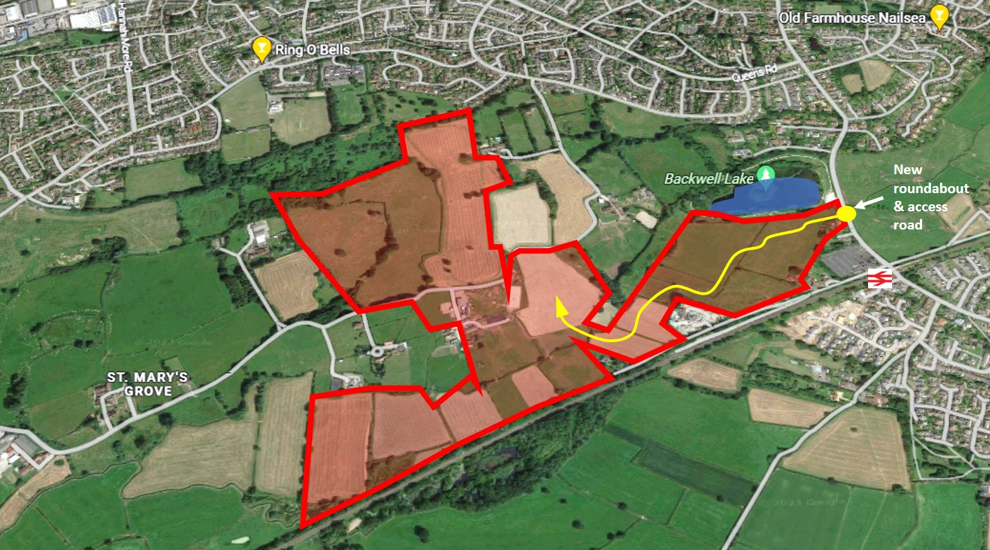

The developer, Gleeson Land, has assembled a 94-acre site, and has plans to build 400 new homes, mainly within Nailsea’s boundary, but with part of the site in Backwell Parish. The principal (and possibly only) vehicle access to the site would be via a new road off Station Road, between the entrance to the Lake car park, and the railway bridge. It would create a major extra traffic issue on the already congested Station Road. It would be an urbanisation of what is currently tranquil countryside, and would severely compromise the present Nailsea / Backwell Strategic Gap. So far, the developer has only tested out proposals, prior to submitting an outline planning application.
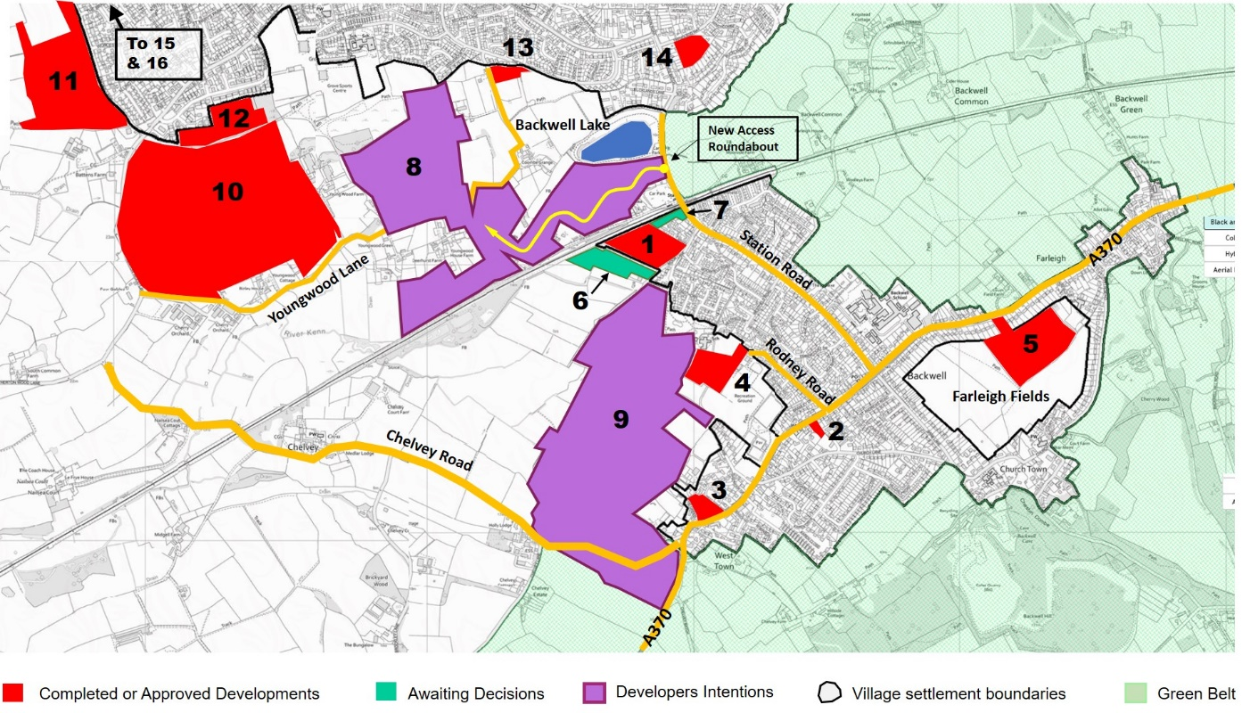
Recent Past, Current & Potential Development Map

 | Location | Houses | Status | Comment
 | Backwell
1 | Coppice Place | 65 | Completed | Now occupied
2 | Red Cross site | 8 | Completed | Now occupied
3 | New Inn site | 9 | Completed | Now occupied
4 | Rodney Road (Scout Hut) | 65 | Approved*** | Serious issues remain with the access etc
5 | Farleigh Fields | 119 | Approved*** | Serious issues remain with drainage etc
6 | Even Keel, Moor Lane | 65 | Awaiting decision | Revised plan with fewer houses expected
7 | Backwell Motors | 7 | Awaiting Decision | Part continuation of business, part residential
8 | Gleeson | 400 | Speculative | Application expected shortly
9 | Grove Farm | 700 | NSC considered | In previous draft Local Plan
 | Nailsea
10 | Netherton Wood | 450 | Well under way | Taylor Wimpey – “Netherton Grange”
11 | Engine Lane | 171 | Well under way | Barratts – “Parish Brook”
12 | Uplands | 52 | Approved | North Somerset Council (NSC)
13 | The Perrings | 14 | Underway | Clifton House “Paddock Rise”
14 | Trendlewood Way | 24 | Approved | Acorn Group “Bucklands Place”
15 | Causeway View | 450 | Speculative | Vistry “Causeway View”
 | Tickenham
16 | Ryves Vale | 32 | Completed | Newlands – near golf course on B3130

***Reserved Matters (RM) is the technical term for the detailed documents and NSC conditions required for full planning consent. The RM require the developer to submit, and get formally approved, such crucial issues as road and housing detail, drainage proposals and landscaping obligations. In most cases, the RM must be approved before work can start, but in some instances, it is acceptable for detail to be submitted and approved as work progresses.

Rodney Road The developers, Taylor Wimpey, held a public exhibition on 8 March to present their proposals with some of the detail required for a Reserved Matters application. Residents were encouraged to attend and make their views known.

Farleigh Fields Persimmon started to submit some RM in late 2022, which BRA and others felt were worthy of challenge. Recently, Persimmon has temporarily withdrawn the RM, for later submission. These details will, in due course, be carefully analysed by NSC and BPC (and also monitored by BRA). It seems probable that any development work will not start here for many months. Discussions on the option for Backwell Parish Council (BPC) to acquire the Local Green Space fields for £1 are currently on hold.

North Somerset Council Local Plan 2038

North Somerset Council (NSC) is obliged under current legislation to produce a 15-year Local Plan. During 2021 and 2022 they embarked on this task, and a draft plan was published in Spring 2022. To our surprise, the draft proposals included an allocation of 1100 new homes in Backwell – which would effectively turn the village into a town!

There was strong resistance from residents concerned about the large proposed number of new homes, removal of green belt, local traffic congestion, pressure on local services, and damage to the local environment. The original timescale for agreement and ratification of the new Plan was end 2023. This date has been significantly deferred, arising from new central government proposals and the district elections in May. It now seems likely the new Plan will not be ratified until late 2024, and will become Local Plan 2040.

The proposed National Planning Policy Framework (NPPF) is likely to include changes to the way housing supply numbers are calculated (giving local Planning Authorities much more control rather than being dictated to by a standard algorithm). It will amend Green Belt policy, prioritise valuable farm land (for food production) etc, which will require a re-think to the NSC draft Plan. It seems likely that NSC will accept that proposals for a new road crossing the railway (from the A370 near Fairfield Way) towards Nailsea would be prohibitively expensive and un-fundable. Without such a road, the likelihood of large-scale new development on the Bristol side of Backwell is reduced.

A revised draft plan will be published later this year and it is expected that the new housing allocation for Backwell will be significantly reduced. New ideas for an upgraded link from Nailsea to Bristol via Failand are being explored by NSC. This would ease traffic pressure on Station Road and at Backwell cross-roads. However, we await more details of the revised draft Plan with bated breath!

Bristol Airport Expansion

In February 2022, following a three-month Inquiry, the planning inspectorate granted permission for Bristol Airport to expand its operations from 10 million to 12 million passengers per annum, concluding that the economic benefits arising from the proposed expansion outweighed the harm to Green Belt, increased noise, and other environmental factors. This decision was upheld by the High Court on 31st January 2023, following a legal challenge by BAAN (Bristol Airport Action Network) which was rejected. Justice Lane, whilst sympathetic, said environmental decisions had to be taken at Government level. BAAN contends that there is a strong case on the grounds of environmental law to take the decision to the Court of Appeal, but this process is likely to take several months. Bristol Airport now has permission to expand and will be able to achieve its fully coordinated status, which means 24 / 7 operation and more night flights. Bristol Airport’s review of our airspace this year could mean a change to flight paths, heights of planes and banking sooner after take-off. Bristol Airport is now working on its consultation strategy when local communities will be able to see the new plan and comment. BRA and Backwell Parish Council will continue to monitor activities, with the help of the Parish Councils Airport Association (PCAA).

Climate Action

BPC has recently created a Climate Action Working Group with the aim of developing a Carbon Reduction plan for the village. This group, composed of village organisations, including BRA, and interested local residents, meets monthly and will be leafleting residents on how to calculate personal carbon footprints and ways to reduce them. They will also be hosting an event in the village on 22nd April, Earth Day. Please watch BBC Frozen Planet 2's last programme to be convinced that a large number of individuals can make a difference! If you wish to be part of the group, please email 37westtown@gmail.com.

Jubilee Stone footpath

Residents were shocked last summer when a popular footpath to the Jubilee Stone was closed by the landowner. We encouraged members to provide a witness statement if they had made use of this and two other paths. BPC coordinated this activity and submitted an application to NSC (with over 80 witness statements) to have three paths in the field recorded as Public Rights of Way. It could take a year before a decision is made, but we are hoping for a positive outcome.

Backwell Recycling Centre (BRC)

NSC included closure of BRC amongst many savings measures in this year’s budget. Following public pressure this has been removed and BRC will remain open.

Coles Quarry

Residents with long memories may recall that permission was granted in 2015 for the creation of 15 industrial units in the old Coles Quarry area. No work appears to have been carried out to implement this, and the refurbished old weighbridge house remains empty and unused.

Ex Mica site

A development on this prominent site will be very welcome but BRA has objected to the recent application on several grounds, including traffic and pedestrian safety, building design and quality.

Making Nailsea & Backwell Station Accessible

Wheelchair users, pushchair users and those with mobility problems have campaigned for many years (supported by BPC & BRA) to make platform 1 (trains to Weston) accessible. It is frustrating that Backwell is deemed to have excellent transport links when housing is proposed for the village, but many people are unable to climb to the station platform. Proposals have been put forward in the past, but at the present time there is no commitment or funding to solve the problem.

Chairman’s Reflections

Some of you might be reading our annual Newsletter for the first time – I hope you find it useful and interesting. As a committee, planning issues tend to dominate our priorities but we tackle many other topics and do our best for the village and the surrounding countryside. In these notes I hope to highlight the most important issues facing our village.

Looking back

This last year has seen some major disappointments.

The NSC draft Local Plan (LP) – the process so far has not given us a warm feeling that the final version will be good for Backwell.

Housing developments – after many different planning applications, huge local opposition, refusals and appeals over several decades, Persimmon was finally given outline consent by an Appeal Inspector to build up to 125 houses on one of the Farleigh Fields. Then, Taylor Wimpey (TW) were given outline consent by NSC to build up to 65 houses in the field off Rodney Road, again despite huge local opposition. Both these consents happened because NSC was not able to demonstrate a satisfactory ‘Five Year Land Supply’ – unfortunately this factor outweighs all other considerations including local opinion.

Bristol Airport – BRA’s position is that the airport is big enough and further expansion is not appropriate. Unfortunately, despite widespread opposition and a refusal by NSC, consent to expand was given at Appeal. Noting the totally inadequate public transport and road system, we foresee ever increasing traffic issues, particularly for Downside.

Looking forward

Local Plan – NSC has been facing considerable challenges due to nationally imposed housing targets. However, we think the previously proposed further large-scale development around Backwell and Nailsea would have an unacceptable impact on the local area and cause very serious traffic issues. We note that revision of national planning documents, proposed new legislation and May’s local elections will delay production of the next draft Local Plan. Together with the Parish Council, we will continue to engage with NSC and hope the next version will be better for Backwell! The longer the uncertainty continues, the greater the risk of speculative development.

Housing developments we will continue to engage with NSC’s planning process as T-W and Persimmon submit their detailed plans for the Rodney Road and Farleigh Fields developments.

Gleesons’ proposal – if this were to go ahead, we think it would seriously compromise the separate identity of Backwell, severely impact the tranquillity at the lake, and cause even worse traffic problems. Therefore, we consider it completely unacceptable and will do our best to support BPC and Nailsea Town Council in opposing it.

Climate Action – noting the declared international, national and local climate / nature emergencies it seems likely this issue will form an increasing part of our future activities.

Despite all the disappointments and challenges, we will continue to do our best for the village, working with BPC and other organisations. Another busy year ahead!

It would be good to see you at our AGM.

Would you like to join our committee and help look after Backwell? Feel free to contact me.

Best Wishes Keith Riches

Backwell Residents Association Annual General Meeting

This year’s ANNUAL GENERAL MEETING will be held at 7.00pm on Tuesday 18 April 2023 in the Sixth Form Lecture Theatre at Backwell School (entrance via Meadow Close off Station Road).
Agenda
- Apologies for Absence
- Approval of 2022 AGM Minutes (available on website or on request to Hon. Sec.)
- Chairman’s Report
- Membership Report
- Honorary Treasurer’s Report and Audited Accounts for year to 31st December 2022
- Election of Officers*, Honorary Secretary, Honorary Treasurer and up to five Committee Members. The following Nominations have been made at the date of this Notice:

Hon Secretary | Mike Veal | Proposed | Judy Thomas | Seconded | Geoff Wells
Hon Treasurer | Kevin Crawford | Proposed | Mike Rose | Seconded | Mike Veal

The following Committee Members, having served three years are retiring at the Annual General Meeting and offer themselves for re-election.

Committee Member | Gill Collinson | Proposed | Valerie Wells | Seconded | Keith Riches
Committee Member | Chris Elliott | Proposed | Jo Watson | Seconded | Terry Merrett-Smith
Committee Member | Barbara Harland | Proposed | Mike Veal | Seconded | Mike Rose
Two vacancies*

- Appointment of Auditor:

Auditor | Richard Gaunt | Proposed | Mike Rose | Seconded | Valerie Wells

- Any Other Formal Business
- Guest Speakers, Lucy White (Planning Consultant) and Councillor John Sleigh, and Open Forum

*Nominations for the Committee vacancies should be made to the Honorary Secretary, 36 Longthorn, Backwell, BS48 3GY at least 24 hours in advance of the Meeting. Nominations must be proposed and seconded by members in full membership for not less than three months prior to the Annual General Meeting and signify the nominee’s willingness to serve. Members are reminded that the Committee has authority to co-opt additional members as necessary to undertake specific roles. We are particularly interested in recruiting a Committee member with knowledge or experience of planning law and procedures. Please contact the Chairman or Secretary if you would like to discuss this possibility.

NB: The Meeting is open to everyone but only paid up members may vote or make nominations. The formal aspects of the AGM will be kept to a minimum so that we can devote most of the time to the matters covered in the attached newsletter and other matters raised by members.

Current Elected Committee Members:
Barclay, Karen – (Parish Council Liaison)
Collinson, Gill – (Recruitment)
Crawford, Kevin – (Treasurer)
Elliott, Chris – (Projects and Meetings Co-ordination)
Harland, Barbara – (Airport, Traffic and Re-Cycling)
Kemp, Margaret – (Membership & Web Manager)
Ribbon-Miles, Angela – (Social Media)
Riches, Keith – (Chairman) – 462908
Rose, Mike – (Planning Specialist)
Veal, Mike – (Secretary) – 461187
Wells, Geoff – (Publicity and Communications) – 462627
Wells, Valerie – (Recruitment) – 462627

Current Co-opted Committee Members:
Stewart, Bruce – (former Chair and Secretary)
Veal, Sue – (Minutes Secretary)

The BRA Committee is mindful of the fact that we are a membership organisation, and that often a planning application will have both positive and negative aspects. We welcome comments from our members at any time. We look forward to welcoming our members and non-member residents to our AGM. Over 430 Backwell households with approximately 750 adult members paid subscriptions for the period to 31st December 2022. Renewal subscriptions of £10 per household were due on the 1st January to cover the year to 31st December 2023 and we are grateful to those households who have already renewed their membership. Any household which joined in the last three months of 2022 will have its membership carried forward to 31st December 2023.
A membership application / renewal form is attached and we hope that, if you have not already done so, you will join or re-join to strengthen our representation and increase our funds upon which there are likely to be heavy demands this year in protecting our village from over-development.

Visit our website at www.backwellresidents.org.uk
E-mail us at backwellresidents@btinternet.com

Backwell Residents Association Membership Form
Period up to 31st December 2023

I / We would like to (re-) join Backwell Residents Association.

Forename: Surname:
Forename: Surname:

Address: …………………………………………………………………………………………………….

Post Code: …………...…….… Telephone: …………...………………...………………...…...

Email: …………………………………………………………………………………………...……........

Please supply an email address if at all possible. Our main distribution method is by email bulletins, which are fast and cost nothing. Newsletters are much less frequent.

Membership Subscription £10 per household per year
(gives votes for all household members aged 18 and over) £ 10

I / We wish to make an additional, optional donation to BRA £____

(Cash / Cheque payable to Backwell Residents Association)

TOTAL £____

Signed: ……………………………………….…………………... Date: ……………………………...

Help is welcome with deliveries, BRA admin, IT skills, other specialism etc.
Please state below if you would like to offer assistance

………………………………………………………………………………………………………………

Please return this form and money to the BRA drop box inside the Post Office or to Mike Veal, 36 Long Thorn, Valerie Wells, 8 Bramley Drive, or to any other BRA committee member.

Or renew by electronic transfer to: Nat West sort code 60-14-49,
Account No 05005531 giving your surname, house number and street. Please also email us on backwellresidents@btinternet.com to add or confirm your contact details on our membership list. Better still please set up an electronic annual standing order.

Visit our website at www.backwellresidents.org.uk . This is kept up to date with all our communications, links to other websites etc. It is a valuable resource.

Backwell Residents Association Objectives - BRA will work to safeguard and promote the collective interests of Backwell residents in matters concerning social, economic and community life and the character of the village.

The Association will support or oppose development affecting Backwell having regard to residents’ interests and the local environment.

GENERAL DATA PROTECTION and PRIVACY REGULATIONS (GDPR) The details you supply on this membership form will be kept on the BRA database and used for internal admin purposes and will not be shared with any other organisation. It will be used to keep you informed by bulletins and newsletters on matters in furtherance of BRA objectives. By joining BRA, you give permission for us to store your information and you agree to BRA sending you information to your address, or to your email or (exceptionally) by phone. You may contact us at any time to cancel this arrangement. BRA abides by the principles of the GDPR, and will maintain the security and privacy of your personal information

