Dear Member 8th January 2022

(This email is attached as a pdf for those wishing to print a hard copy)

We hope that 2022 will be a better year for all members.

We think it would be useful to identify the projects that will be decided in early 2022, some of which will have a major impact on Backwell. Residents have made their views known on some of these, and we await the decisions.

Rodney Road – Proposal for 65 houses by Taylor Wimpey (TW)

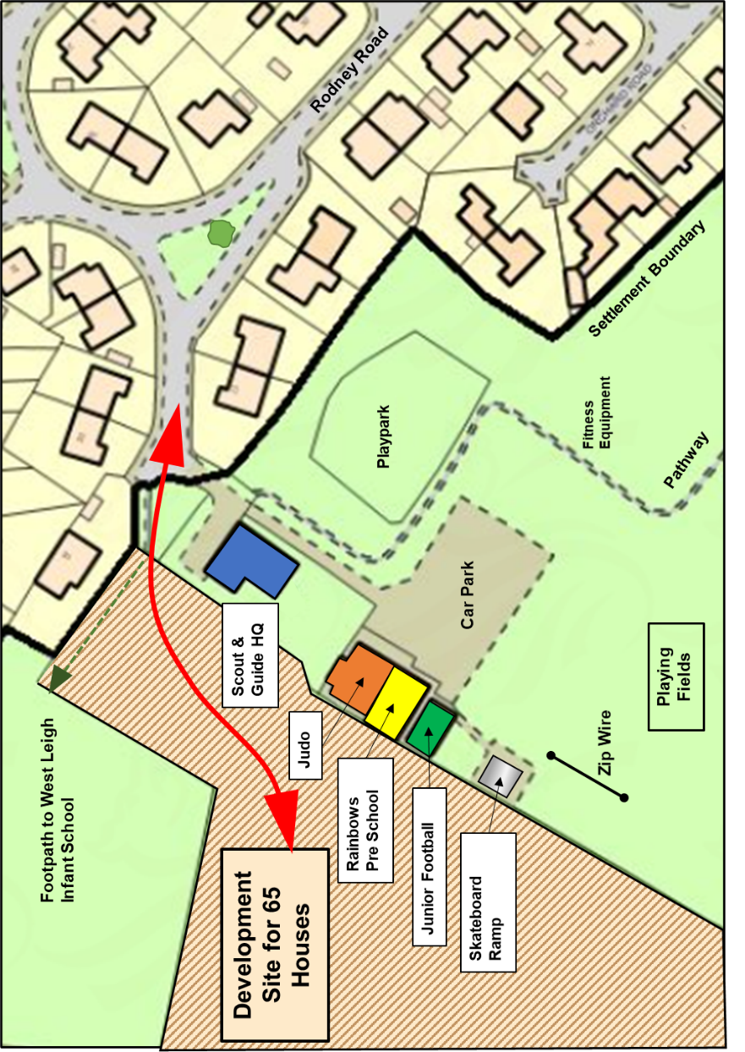
North Somerset Council (NSC) has delayed a decision on this, which is now expected to be taken by its Planning and Regulatory Committee at a meeting either on Wednesday 19th January or (more likely) Wed 16th February. The entrance to the development site is shown below.

Bristol Airport

The result of the appeal by Bristol Airport into NSC’s decision to refuse the expansion to 12 million passengers per year is expected in the near future. There is a separate issue of flight paths being reviewed, which may affect Backwell residents. This is being monitored closely, and we will keep members informed.

North Somerset Local Plan

NSC has been preparing the draft North Somerset Local Plan for consultation. This key document is also expected to be released in the near future.
Farleigh Fields - proposal by Persimmon for 125 houses

This application was refused by NSC in September 2021, but Persimmon has appealed against this decision. It will be considered by a Government Inspector, Ms Andrea Mageean, at an Inquiry which will start on Tuesday 15th March, at Weston Town Hall, and is estimated to take 8 days. These details may change depending on the pandemic situation, including the possibility of holding the Inquiry virtually.

On Dec13th NSC wrote a letter to residents who had commented, which invited anyone wishing to make further comments to do so by January 10th. BRA pointed out an error in the email address quoted in this letter. NSC sent a further letter, dated December 30th with a revised deadline of January 27th.

What can residents do? If you commented on the original application, your comment will be considered by the Inspector at the appeal, so there is no need to repeat it. If residents wish to raise new issues, or amend what they said, it is recommended that these are submitted in writing by Thursday 27th January.
Comments may be made on-line at:

https://acp.planninginspectorate.gov.uk by quoting the 7- digit ref 3285624, and using the “make representation” and “save and continue” buttons.

or by emailing holly.dutton@planninginspectorate.gov.uk

BRA, Backwell Parish Council (BPC), Backwell Resistance (BR) and NSC are working together to coordinate their activities, and determine how to make the best use of professional inputs. NSC has the significant cost of a barrister. BRA and BPC are sharing the costs of other professionals. BRA, BPC and BR will be suggesting witnesses to speak at the Inquiry, reflecting the mix of reasons for objection. They will “speak from the heart” as a complement to the more technical matters. Anyone who has lodged an objection can ask to speak, though the Inspector will decide how many she wants to hear.

Attendance at Weston.

It is helpful at an Inquiry if the Inspector is aware of the level of interest in the village, with seats allocated to the public being reasonably full. Nearer the date we will advise members of the detailed programme. At the last Inquiry there were usually at least one member from BRA and one from BPC present at any time, along with other residents from time to time.

The Farleigh Fields site is shown below as a reminder.
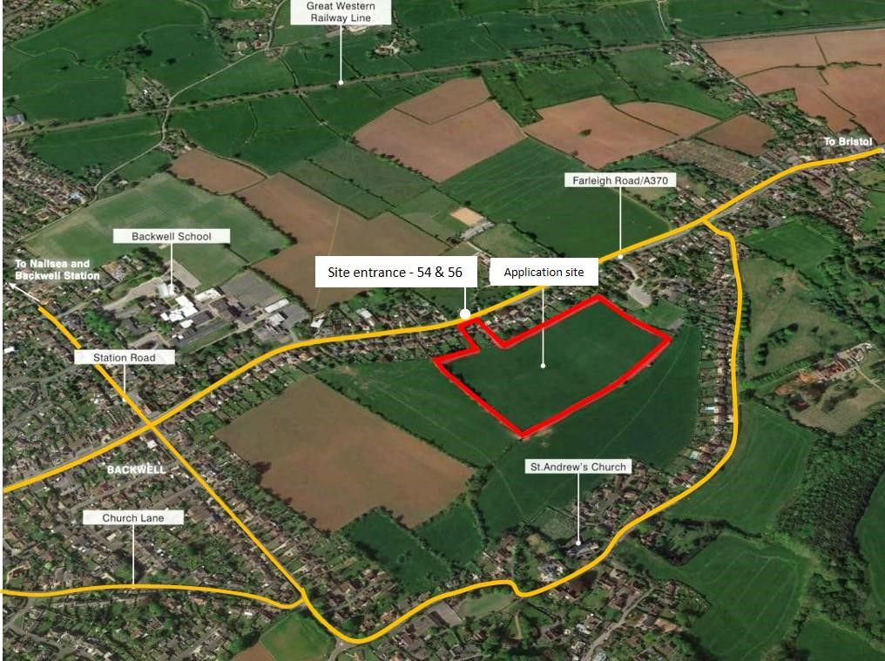

Clean Air Zone (CAZ) in Bristol

Members will no doubt be aware that Bristol City Council has been debating this issue. Proposals have now been firmed up and the implementation date is not far away – in ‘Summer 2022’

Details can be found on: Bristol's Clean Air Zone - bristol.gov.uk

The charge will be £9 for any day when you enter the zone. It applies, in broad terms to petrol cars older than 2006 and diesels older than 2015. Bristol CC estimates that 71% of vehicles will be unaffected.

The reason for mentioning it is that the CAZ includes the Cumberland Basin and part of the Portway – both of which are common routes for many Backwell drivers.

Members of the BRA committee are meeting our MP, Liam Fox, later this month, mainly on housing targets etc. We will also raise our concerns on the CAZ, since the inclusion of the Basin and Portway could encourage drivers to take long routes on narrow lanes within North Somerset to avoid the charge.

Covid Support

Throughout the pandemic Backwell people have done an amazing job of looking out for each other. If there is a situation where a resident needs more assistance, local groups are working together through Backwell Life – you can contact them on 07851 438530 and email at backwell.life@gmail.com

BRA AGM

We have made a booking for a live AGM on Tuesday April 5th, at our usual venue in Backwell School. This is of course, subject to much uncertainty, and we will review the situation nearer the date.

BRA Membership

We are grateful to our 440 households who were BRA members in 2021. A high membership level means that our comments are taken seriously, and the £10 subscriptions enable us to employ professional help when required, as it is at the moment! You can download a membership form for 2022 here , which gives details of payment method by cash, cheque or bank transfer. We should be most grateful if you would send your subscription promptly so we have a good start to 2022.

From your BRA Committee
Visit our website on www.backwellresidents.org.uk
Email us at backwellresidents@btinternet.com

