BRA Bulletin July 2022

Dear Member

Following an extremely active period during the past couple of months, this bulletin gives an update on several planning applications in the village.

Bristol Airport

After the long Inquiry held between July and October last year, the Inspector, in Feb 2022, decided in favour of the Appeal by Bristol Airport, allowing it to expand up to 12 million passengers pa. NSC said it would not contest this decision. However, the process has not quite ended!

One of the very active opposition bodies, Bristol Airport Action Network (BAAN) has collected sufficient funds to obtain a Judicial Review which has been set for November 8th and 9th of 2022. This will be heard by a senior High Court judge and be held in the Bristol Civic Justice Centre, Redcliffe Street. Members of the public may attend, but we understand that there is no opportunity for further comments, as the hearing will concentrate on legalities. More news nearer the date.

Housing Numbers, the Local Plan and Land Supply

This is a complex subject, which has a crucial bearing on the North Somerset Local Plan. Housing requirements are set by central government for Planning Authorities, which in our case is North Somerset Council (NSC). For the Local Plan 2023-38, the requirement is 20,085 houses. The draft Local Plan produced by NSC currently shows 18,046, which includes 1100 houses for Backwell, and still falls short of the target. The centrally imposed targets have been widely challenged, and our MP, Liam Fox has spoken against the impact on North Somerset in Parliament. It is felt by many that North Somerset (NS) has been given an unfair and unachievable target. The area is coping with significant, and character changing developments already, let alone much more in the draft Local Plan. It has also been suggested that the targets should not be considered as absolutely fixed, but some shortfall should be allowed under certain circumstances. A review is possible, but at the moment NSC is working to achieve 20,085.

An earlier target is relevant for current applications, and has produced a need to show a 5-year housing land supply of 7,308 houses over the period 2021 to 2026. Currently, NSC claims that it is able to show this number of houses can be delivered within the timescale, and its supply represents a 5.2-year supply. However, the Farleigh Fields Appeal Inspector considered this was not realistic and concluded that the supply was only 3.5 years, given the inevitable delays in planning and building. This shortfall is serious and played a big part in the Farleigh Fields decision, and also others in North Somerset. It is an unattractive backdrop for the Rodney Road housing application..

Rodney Road – Application for 65 houses

It is expected that this application will go to a NSC Planning Committee shortly. BRA considers there is strong evidence to reject the application, but the need for housing numbers will be a factor, as explained above.

Farleigh Fields

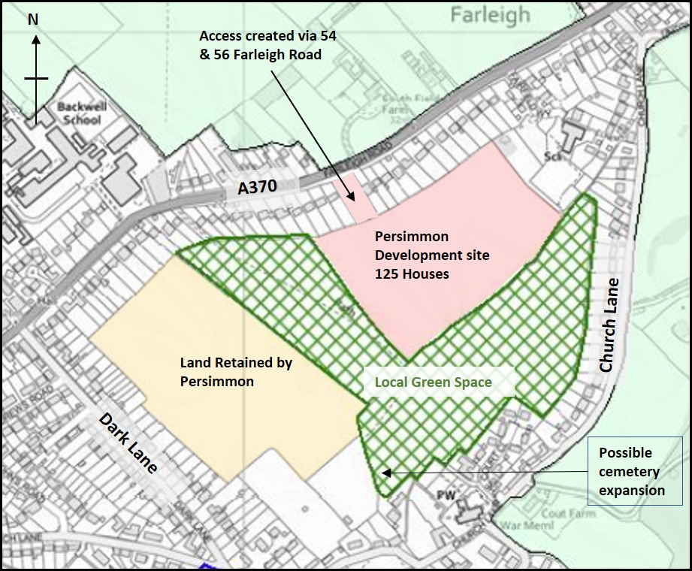

The BRA bulletin of 22.6.22 gave the sad news that the Inspector had allowed the appeal, and that the development of 125 houses could go ahead. The 39-page report is thorough and gives details of her analysis, and she concludes:

“the adverse effects of granting Planning Permission would NOT significantly outweigh the benefits.”

Since the 1980’s, Backwell residents have opposed any building on FF in different parts of the fields and with proposed house numbers as high as 350. The efforts to “save” the fields have not been fruitless, given this development is the smallest ever put forward.

The following points emerge from her Appeal Decision:

- All the indications from NSC and their advisers show that there is no prospect of taking opposition to the application any further.
- The primary benefit of the development was adding 125 units to the housing supply.
- The main adverse effect was the impact on the character and tranquillity of the site, but the Inspector downgraded the impact on the fields compared with the 2018 decision, where the new houses would have been much more visible.
- She recognised that for some houses adjoining the site there would be a “significantly adverse visual effect”. (In layman’s terms, their view of the fields and church would be replaced by a housing estate close to their boundary!)
- The loss of good agricultural land was considered to “weigh modestly against the proposal”
- Other factors including traffic, flooding, impact on wildlife were considered in some detail, but were not felt to be significant given the conditions imposed, and work done to mitigate the impacts.

Conditions: 38 conditions have been placed on the application, which must be met as the application moves from an “Outline” to a “Full” planning application. One of these is that no dwelling should be in excess of two storeys – to reduce the visual impact.

Section 106 Agreement: This will provide finance for off-site benefits provided or paid by the developer.

Local Green Space (LGS) Land: The Inspector applied “moderate weight” to the offer made by Persimmon for the transfer of the LGS land from its ownership to the Parish Council for a nominal sum of £1. As the map above shows, this is a substantial piece of land, which would remain in the ownership of Persimmon if the offer is not accepted. The current tenant farmer has indicated that he would be prepared to continue to farm the land. There are, of course, costs and management issues associated with land ownership. The Parish Council has created a working group of councillors and others to consider this offer.

Removal of Footpath Gate by Jubilee Stone

The owner of the field adjacent to BET's Nature Reserve has replaced the gate at the Jubilee Stone with barbed wire and an earth bank to stop people using the diagonal path across the field. This path has been used by walkers for many years although it is not a Public Right of Way (PROW). This unilateral action is very disappointing and has caused much adverse comment by BRA members and more widely on social media.

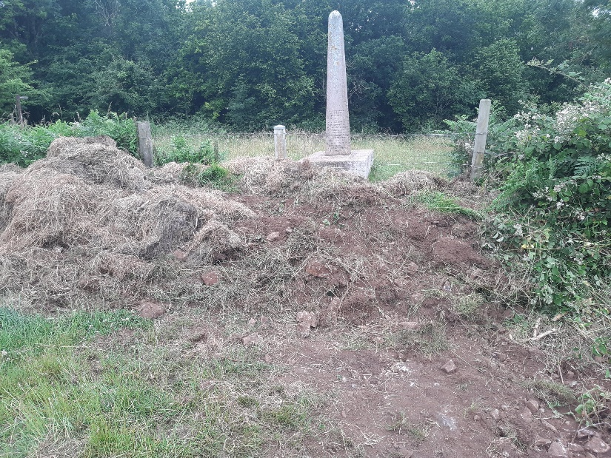

Noting the exhilarating views when walking up and down the open field between the top of ‘Piggy Lane’ and the Jubilee Stone, it is hardly surprising that this route is so often used in preference to the Public Footpaths (PROW), which are not well sign-posted. In fact, the path up the Combe on the eastern edge of the field is almost impassable and, in any event, offers no views whatsoever.

The Parish Council has been investigating the situation and has tried to contact the landowner who has not responded. The issue was discussed at the Parish Council meeting on 7th July; BRA and one other resident made statements. The Council decided to continue investigations with NSC before deciding what to do.

Members who could provide an affidavit confirming dates of earliest use of the diagonal path, the gate, and the stile which preceded it, is invited to contact BRA. Dated photographic evidence would be especially helpful. If a solution cannot be found with the owner, there is an option to try to create a “permissive path”, shown in red on the map, by proving continuous use for 20 years. We will pass on information to the Parish Council, which is leading on this unfortunate matter.

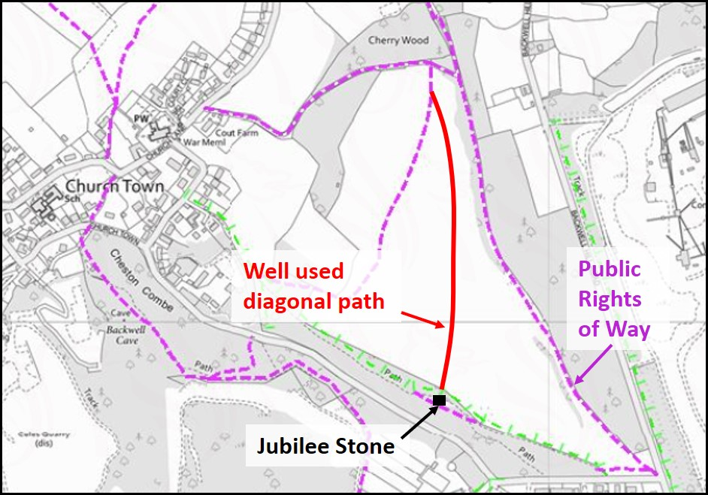

Source: NSC Planning Map

Even Keel

There are 59 objections, and 5 in support of this application for 55 houses on Moor Lane. It has not been decided, but NSC has said “at this stage it is considered unlikely that Highways and Transport will approve the access arrangements proposed for Moor Lane”

Backwell Motors (Ref 22/P/0696/OUT)

An outline application for this site has just been posted on the NSC website. It will involve the demolition of the petrol forecourt and main garage, and the creation of 7 small terraced 3 storey houses facing Station Road. Other buildings at the rear will be demolished, but rebuilt to provide a relocated Equicraft shop and a small garage workshop.

The link for the application can be found here

From your BRA Committee

Visit our website on: www.backwellresidents.org.uk

Email us at: backwellresidents@btinternet.com

