North Somerset Local Plan (LP) 2023 - 38
Dear Member 14th February 2022

Our email bulletin on 26.1.22 was the day after North Somerset Council (NSC) published the Draft North Somerset Plan. We showed the map with the proposed locations for 1120 new houses in Backwell. We have now had time to study the plan more closely, and realise that a larger scale map is required. This is given below:
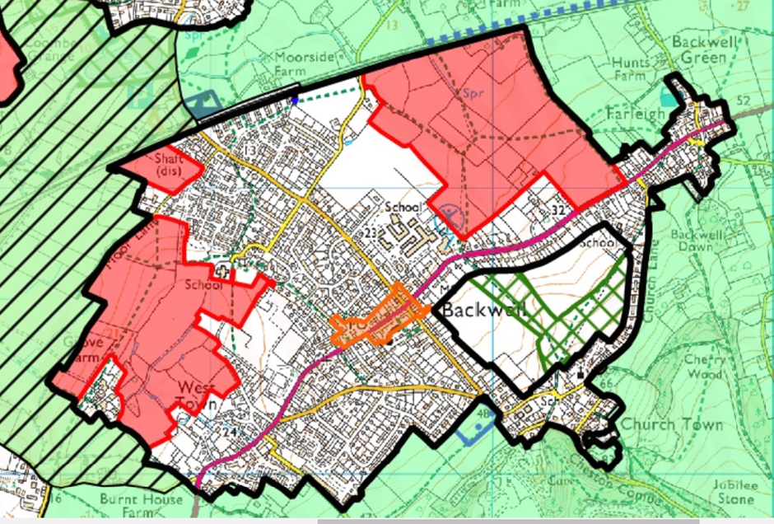

Key points to note are:
- The red areas are newly proposed housing developments of 600 for Grove Farm and 500 for East Backwell. (The small development of 20 houses off Moor Lane may not be in the correct location).
- There is no indication yet of how these developments would be accessed.
- There is also no indication of new roads, which would be needed to cope with this big increase, and with the extra housing planned for Nailsea nearby.
- Given the serious concern many feel with our current inadequate road network, there will need to be large changes, which will impact areas outside the development sites.
- Backwell has coped with the sustainable expansion in housing that was agreed by residents for the period 2014-2026, in our current Neighbourhood Plan. This had provided some 100 houses, a fraction of what is currently being proposed by NSC.

Several features of the Plan are of concern:
- The present number of houses in Backwell of around 1950, will rise to 3070 over the 15 years of the LP, an increase of nearly 60%.
- The fields in East Backwell are all in the Green Belt, which should only be used for building in exceptional circumstances. Currently it is predominantly used for agriculture, with well-used footpaths across the open ground. The housing development will be adjacent to a stretch of the A370, and border the Leisure Centre and Backwell School Playing Fields.
- The Grove Farm development will include the field behind the Scout Hut, and will deprive West Leigh Infant School of its rural surroundings. The track which is the continuation of Moor Lane, that currently leads to open land, will have the new housing on one side.

Next Steps
The above comments are general ones and do not include some points in the LP of a technical nature where it conflicts with planning objectives. We will be working with our planning consultant to produce a document, commenting on a full range of issues, and will pass these on to residents.

We will be producing our usual BRA hard copy Newsletter for every Backwell household in mid-March, prior to our AGM which will be held live on Tuesday 5 April 2022 at 7.00pm in the Sixth Form Lecture Theatre, Backwell School (entrance via Meadow Close off Station Road), unless the Covid situation changes. All residents of Backwell are welcome to attend.

Consultation
NSC does not start its consultation until March 14, running until April 29. This is the opportunity for residents to make their views known, and we will give members details where to see the consultation document and how to do this nearer the date. In the meantime, BRA hopes that we will have a large response to a “straw poll” which we are conducting.

“Straw Poll”
This exercise will have little statistical validity, but should give the BRA committee an indication of the views of our members.

If this draft Local Plan is implemented in Backwell for 2023 to 2038, the impact on Backwell would be:

Very Good Good Bad Very Bad

Please email one of these 4 options to us as soon as possible please backwellresidents@btinternet.com

The opportunity to express your views more fully to NSC will come later, and we hwe hope that you will do so.

