Backwell Residents Association Newsletter
April 2024

We invite you to come to our AGM on Tuesday 23 April from 7pm to 9pm
in the Sixth Form Lecture Theatre at Backwell School, entrance via Meadow Close
Members and non – members are welcome to attend
(membership form on the back page)

Our annual Backwell Residents Association (BRA) Newsletter is delivered to over 2,000 Backwell and nearby households by our volunteers, and aims to bring you up to date on important village issues prior to our AGM, where you will be able to have your say. Membership of BRA has the advantage of regular email bulletins giving dates for making comments on planning applications, public exhibitions, details of road closures and other topics.

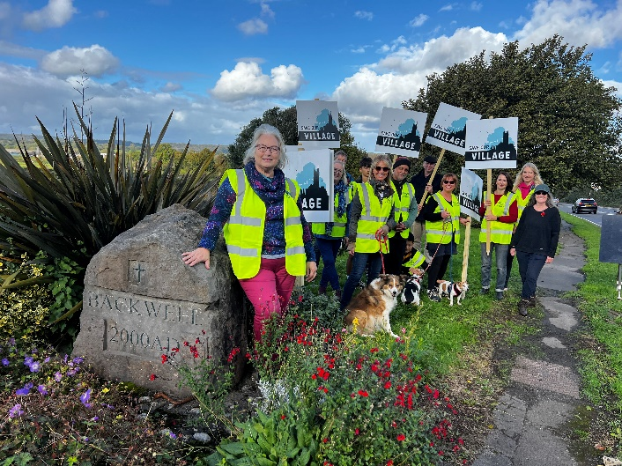
Save our Village

Grove Farm
1280 voices
have objected to Taylor Wimpey’s application for 515 houses at Grove Farm, with a resounding NO! An incredible response that we should be proud of!

Save our Village Submissions from the young, not so young, new residents, and longtime parishioners spoke with one voice sharing their love for our village, its character, their home, and concern for congestion.

- ‘We moved here to gain a sense of community’
- ‘Our roads and lanes can’t cope with further congestion and pollution’
- ‘We chose village life. This will turn us into a town without amenities or resources’
- ‘We love living in a village surrounded by fields and real countryside’
- 'We should be protecting prime agricultural land’
- ‘Please don’t destroy our wildlife, the deer, the badgers, the bats and the little bugs’

The campaign saw a real coming together of hearts and minds. This was a truly amazing achievement, with combined efforts from Backwell Parish Council (BPC), Backwell Resistance (BR) and BRA. It has been an inspiration to see the wide-ranging objections from such a large cross section of residents. Whatever your contribution to the campaign, big or small THANK YOU! Our shared sense of identity and belonging is what makes our village special.

Grove Farm (7) – the way forward? For the time being the village has done all it can to resist this unwelcome planning application. It is likely to take North Somerset Council (NSC) several months to assess and its inclusion in the draft Local Plan is a further complication. Lobbying will continue behind the scenes.

Recent Past, Current and Potential Development in Backwell
 | Location | Houses | Status | Comment
1 | Colliers Gardens | 65 | Completed | Now occupied
2 | Red Cross site | 8 | Completed | Now occupied
3 | New Inn site | 9 | Completed | Now occupied
4 | Rodney Road (Scout Hut) | 65 | Approved | Serious issues remain with the access etc
5 | Farleigh Fields | 119 | Approved | Serious issues remain with drainage etc
6 | Even Keel, Moor Lane | 35 | Awaiting decision | NOT IN draft Local Plan
7 | Grove Farm | 515 | Awaiting decision | IN draft Local Plan
8 | Gleeson | 400 | Awaiting decision | NOT IN draft Local Plan

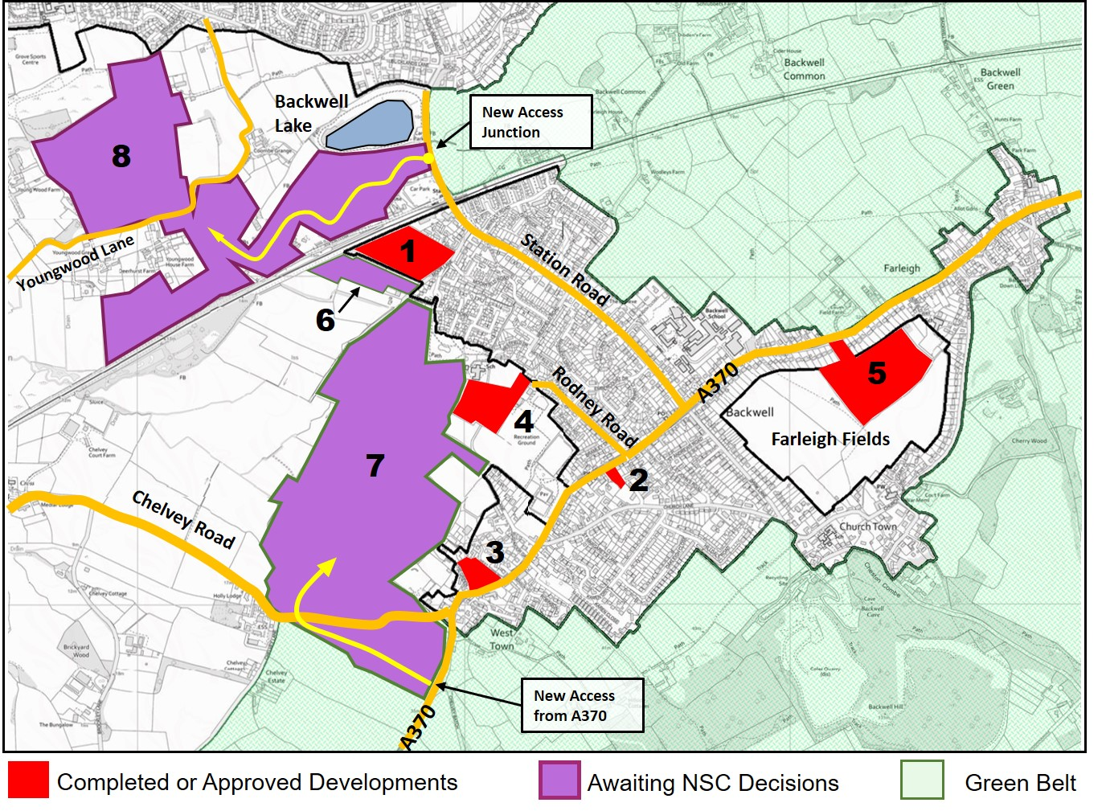
North Somerset Draft Local Plan (LP) 2024 – 2039
There were only 457 individual responses to the LP from the whole of North Somerset. The Grove Farm development on its own had 268 objections to its inclusion in the plan.
NSC is working towards submitting the LP for final examination later this year. It seems likely the final draft will still include land west of Backwell (principally Grove Farm) for housing development. However, there is still the opportunity for the Planning Inspector, having digested the substantial number of valid objections, to overturn or amend this part of the Plan.

New Neighbourhood Plan?
Backwell’s Neighbourhood Plan (NP) was written in 2015, and once the new Local Plan is ‘made’ the NP will effectively become redundant. There are important advantages in having an up-to-date NP, including receiving an increased percentage of finance from any Community Infrastructure Levy. The Village is being encouraged to start seriously considering preparing a new Plan. This will be a challenging task. Ideas on who will do this and how it can be undertaken are needed.

Rodney Road Field (4)
After nearly 4 years Taylor Wimpey has now succeeded in obtaining outline planning consent for its site, adjacent to the Scout hut. Partly thanks to the many local objections and concerns, the consent comes with a long list of conditions and Reserved Matters, which should appease some of these concerns. The consent brings the benefit of over 20 much needed "affordable dwellings", and will contribute considerable Community Infrastructure Levy. However, it will destroy for ever some popular country walks and views so close to the village centre, and we still have concerns over child safety issues near the new site entrance, and the impact of extra traffic in Rodney Road.

Farleigh Fields (5)
Consent was granted in 2022 for about 119 houses as shown on the adjacent map. Persimmon is currently slowly processing the large number of conditions and Reserved Matters required to be approved. Some of these are critical to the development’s effect on the surrounding village - notably drainage and flooding issues, the design and appearance of the new houses, and perimeter landscaping. BRA is monitoring these as they emerge, employing professional advisors when considered appropriate, and keeping in touch with NSC and BPC. We are also aware of Persimmon’s declared intention to develop its additional field behind the Dark Lane houses. Many residents are keen for BPC to take up the option of ownership of the adjoining Local Green Space fields from Persimmon. A decision on this opportunity will be required soon. BRA is working with BPC to assess this complicated and far-reaching decision.

Even Keel, Moor Lane – Octavia Homes (6)
This site has currently one dwelling in a large garden. The latest application is for 35 houses. This would bring some much-needed modest sized houses into the village. However, the vehicular access to the site is felt to be wholly inadequate. BRA and many local residents continue to oppose it.

Gleesons Site – Nailsea / Backwell border (8)
This outline planning application for 400 houses was submitted to NSC in June 2023, and a decision is awaited. The development would have a considerable impact on the strategic gap between Backwell and Nailsea. Traffic to and from the site would access the already over loaded Station Road, at a new junction near Backwell Lake, destroying its tranquillity. There have been many objections including both local Councils and BRA. Crucially, National Highways has stated that Gleeson has not shown that the proposal for the road network would be safe, and NSC should not make a decision for 6 months. Additionally, other official bodies have concerns with drainage, flooding and the impact on bats.

Coles Quarry
NSC Enforcement has been working closely with the Environment Agency in order to reach a resolution regarding the dumping of material in the disused quarry. The lower level is a sensitive area with an underground drinking water supply. Part of the resolution has been to remove the material from the lower to the upper level which has consent for 15 light industrial units where spoil can safely be used as hard core. NSC has installed on- site cameras to monitor the works and limit traffic movements. Thank you to those residents who provided information to help hold the relevant parties to account. NSC is hopefully moving towards a positive solution for residents.

Bristol Airport
Bristol Airport is now expanding its operations from 10 million to 12 million passengers per annum. Changes will include a new frontage to the terminal, renovation of the Air Traffic Control Tower and an additional multistorey car park with a transport hub. BRA continues to have a good connection with the Parish Councils Airport Association (PCAA) which monitors activities at the airport to check on intrusions into the Green Belt, noise, night flights, parking issues and expected changes to flight patterns.

Bus Service Improvement Plan (BSIP)
The BSIP proposal for Backwell was the subject of a drop-in session at the WI Hall on Wednesday 29th November, where much local opposition from a very large number of residents was evident.

The proposal has 3 main elements:

* Making Dark Lane one way only up from the crossroads, with no access down Dark Lane to the A370.

* Creating a bus lane on the A370 towards Weston
between the Leisure Centre and the crossroads.

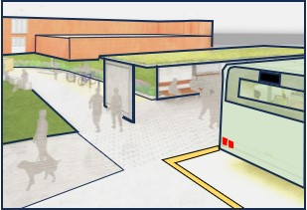
* Creating ‘transport hubs’ at the Leisure Centre and/or the Spar Green

At the time of publishing this newsletter, the results of the consultation have not been published, and no decision has been announced.

Jubilee Stone Footpath
Many readers will recall that in autumn 2022 BPC coordinated a submission to NSC. This submission, with a large number of personal statements, seeks to establish ‘Public Right of Way’ status for three footpath routes on Backwell Hill. It was always known this would be a slow process but the lack of progress to date is disappointing. In the meantime, it is worth mentioning that Backwell Parish boasts a good selection of footpaths which are easily accessible …… assuming it will eventually stop raining! As well as the local OS Map, BPC has copies of a useful little booklet entitled: ‘A Collection of Backwell Walks Including the Backwell Round’. They can be viewed on the BPC website under the ’village’ tab and ‘walks’. In addition to these walks, you can approach the Grove Farm area on footpaths from Moor Lane, behind West Leigh School and from Chelvey Road.

Backwell Motors
Demolition of the interior of the former shop is under way. The Equicraft shop has closed, but the business is continuing on-line only.
The 3 activities in the new development are:
- Harvest Energy petrol, diesel and red diesel pumps will be on site as before
- a Co-op food store, of the same size, or larger than the SPAR in Rodney Road
- Backwell Motors continuing to operate its service, MOTs, etc via Charles Atherton, in the body shop at the rear of the site

Ex Mica site at Backwell Crossroads
This site has been an eyesore ever since MICA closed. The owners applied for planning permission for a development of two flats and two houses, but this was refused in April 2023. The owners are currently trying to sell the site on the basis of the old shop having ground floor ‘business use’ and first floor living accommodation. Given its prominent position, we all hope that a speedy solution can be found.

Festival Way and Backwell Bow Speed Limit
The Festival Way is a largely traffic free cycle route (Sustrans 33) between Nailsea centre and Queens Square in the heart of Bristol. NSC is carrying out improvements to this much used route, mainly at road crossing points. The route includes Backwell Bow, where both cyclists and other road users have expressed concerns about speeding traffic. Following a consultation NSC is intending to reduce the speed limit to 40mph along Backwell Bow. BPC has requested this be changed to 30mph.

BACKWELL RESIDENTS’ ASSSOCIATION

This year’s ANNUAL GENERAL MEETING will be held at 7.00pm on Tuesday 23 April 2024 in the Sixth Form Lecture Theatre at Backwell School (entrance via Meadow Close off Station Road)
AGENDA
- Apologies for Absence
- Approval of 2023 AGM Minutes (available on website or on request to Hon. Sec.)
- Chairman’s Report
- Membership Report
- Honorary Treasurer’s Report and Audited Accounts for year to 31 Dec 2023
- Alteration to Constitution: -
To resolve that the first paragraph of Item 14 of the Constitution last adopted on the 17 November 2015 shall be amended to read as follows: -
“A General Meeting of BRA shall be held by the 30 April in every year to transact the following business: -
to receive and, if approved, to adopt an audited statement of BRA’s Accounts for the Accounting Year ended on the previous 31st December.”

Proposed | Mike Veal | Seconded | Margaret Kemp

- Election of Officers* Honorary Secretary, Honorary Treasurer and up to two Committee Members. The following Nominations have been made at the date of this Notice:

Hon Secretary | Mike Veal | Proposed | Judy Thomas | Seconded | Geoff Wells
Hon Treasurer | Kevin Crawford | Proposed | Mike Rose | Seconded | Mike Veal
Committee Member | Grahame Dixie | Proposed | Keith Riches | Seconded | Barbara Harland
Committee Member | Michael Pratt | Proposed | Geoff Wells | Seconded | Sue Veal

- Appointment of Auditor:

Auditor | Richard Gaunt | Proposed | Mike Rose | Seconded | Valerie Wells

- Any Other Formal Business
- Guest Speaker and Open Forum

*Nominations for the Committee vacancies should be made to the Honorary Secretary, 36 Longthorn, Backwell, BS48 3GY at least 24 hours in advance of the Meeting. Nominations must be proposed and seconded by members in full membership for not less than three months prior to the Annual General Meeting and signify the nominee’s willingness to serve. Members are reminded that the Committee has authority to co-opt additional members as necessary to undertake specific roles. We are particularly interested in recruiting a Committee member with knowledge or experience of planning law and procedures. Please contact the Chairman or Secretary if you would like to discuss this possibility.

NB The Meeting is open to all villagers but only paid-up members may vote or make nominations. The formal aspects of the AGM will be kept to a minimum so that we can devote most of the time to the matters covered in the attached newsletter and other matters raised by members.

Current Elected Committee Members:
BARCLAY, Karen – (Parish Council Liaison)
COLLINSON, Gill – (Recruitment)
CRAWFORD, Kevin – (Treasurer)
ELLIOTT, Chris – (Special Projects)
HARLAND, Barbara – (Airport, Traffic and Re-Cycling and Parish Council Liaison)
KEMP, Margaret – (Membership & Web Manager)
RIBBON-MILES, Angela – (Social Media)
RICHES, Keith – (Chairman) – 462908
ROSE, Mike – (Planning Specialist)
VEAL, Mike – (Secretary) – 461187
WELLS, Geoff – (Publicity and Communications) – 462627
WELLS, Valerie – (Recruitment) – 462627

Current Co-opted Committee Members:
DIXIE, Grahame – (Ecologist)
PRATT, Michael – (Planning)
STEWART, Bruce – (former Chair and Secretary)
VEAL, Sue – (Minutes Secretary)

The BRA Committee is mindful of the fact that we are a membership organisation, and that often a planning application will have both positive and negative aspects. We welcome comments from our members at any time. We look forward to welcoming our members and non-member residents to our AGM. Over 420 Backwell households with approximately 750 adult members paid subscriptions for the period to 31 December 2023. Renewal subscriptions of £10 per household were due on the 1st January to cover the year to 31 December 2024 and we are grateful to those households who have already renewed their membership. Any household which joined in the last three months of 2023 will have its membership carried forward to 31 December 2024. A membership application / renewal form is attached and we hope that, if you have not already done so, you will join or re-join to strengthen our representation and increase our funds upon which there are likely to be heavy demands this year in protecting our village from over-development.

Visit our website at www.backwellresidents.org.uk
E-mail us at backwellresidents@btinternet.com

Backwell Residents Association Membership Form
Period up to 31st December 2024

I / We would like to (re-) join Backwell Residents Association.

Forename: Surname:
Forename: Surname:

Address: …………………………………………………………………………………………………….

Post Code: …………...…….… Telephone: …………...………………...………………...…...

Email: …………………………………………………………………………………………...……........

Please supply an email address if at all possible. Our main distribution method is by email bulletins, which are fast and cost nothing. Newsletters are much less frequent.

Membership Subscription £10 per household per year
(gives votes for all household members aged 18 and over) £ 10

I / We wish to make an additional, optional donation to BRA £____

(Cash / Cheque payable to Backwell Residents Association)

TOTAL £____

Signed: ……………………………………….…………………... Date: ……………………………...

Help is welcome with deliveries, BRA admin, IT skills, other specialism etc.
Please state below if you would like to offer assistance

………………………………………………………………………………………………………………

Please return this form and money to the BRA drop box inside the Post Office or to Mike Veal, 36 Long Thorn, Valerie Wells, 8 Bramley Drive, or to any other BRA committee member.

Or renew by electronic transfer to: Nat West sort code 60-14-49,
Account No 05005531 giving your surname, house number and street. Please also email us on backwellresidents@btinternet.com to add or confirm your contact details on our membership list. Better still please set up an electronic annual standing order.

Visit our website at www.backwellresidents.org.uk . This is kept up to date with all our communications, links to other websites etc. It is a valuable resource.

Backwell Residents Association Objectives - BRA will work to safeguard and promote the collective interests of Backwell residents in matters concerning social, economic and community life and the character of the village.

The Association will support or oppose development affecting Backwell having regard to residents’ interests and the local environment.

GENERAL DATA PROTECTION and PRIVACY REGULATIONS (GDPR) The details you supply on this membership form will be kept on the BRA database and used for internal admin purposes and will not be shared with any other organisation. It will be used to keep you informed by bulletins and newsletters on matters in furtherance of BRA objectives. By joining BRA, you give permission for us to store your information and you agree to BRA sending you information to your address, or to your email or (exceptionally) by phone. You may contact us at any time to cancel this arrangement. BRA abides by the principles of the GDPR, and will maintain the security and privacy of your personal information

